Martin Rikli’s Ethiopia: A German Photographer in Colonial East Africa
Exhibition Object Check List

- Martin Rikli
Germany, 1898-1969
[Emperor Haile Selassie in profile view with Frau Hilde Johanssen], ca 1935-1936
Photograph from Album 1
11.5 x 9cm (original)
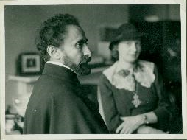
- Martin Rikli
Germany, 1898-1969
[Emperor Haile Selassie on throne with others nearby], ca 1935-1936
Photograph from Album 1
11.5 x 8.5cm (original)
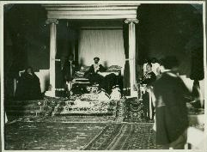
- Martin Rikli
Germany, 1898-1969
[Ethiopian Emperor seated with European Diplomat], ca 1935-1936
Photograph from Album 1
11.5 x 8.5cm(original)
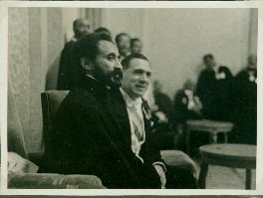
- Martin Rikli
Germany, 1898-1969
[Ministers Bodard and Barton toast with Brandy sniffers], ca 1935-1936
Photograph from Album 1
11.75 x 8.75cm (original)
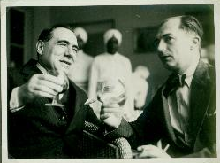
- Martin Rikli
Germany, 1898-1969
[Emperor Haile Selassie seen in background], ca 1935-1936
Photograph from Album 1
16 x 11cm(original)
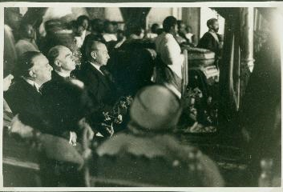
- Martin Rikli
Germany, 1898-1969
[Two Europeans with Emperor Haile Selassie I], ca 1935-1936
Photograph from Album 2
11.75 x 8cm(original)
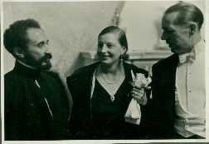
- Martin Rikli
Germany, 1898-1969
[A formal social occasion: Three European women in gowns and furs, along with Empress Menen], ca 1935-1936
Photograph from Album 2
11.75 x 8.5cm(original)
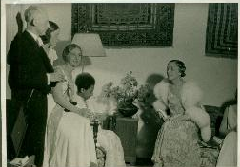
- Martin Rikli
Germany, 1898-1969
[Landscape view of grasslands, trees and mountains], ca 1935-1936
Photograph from Album 1
11.5 x 8cm(original)
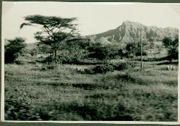
- Martin Rikli
Germany, 1898-1969
[Frau Boud woman shades herself with an umbrella], ca 1935-1936
Photograph from Album 1
8.75 x 12cm(original)
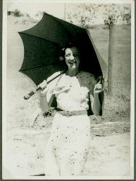
- Martin Rikli
Germany, 1898-1969
[A European woman in a riding outfit poses on a rocky lake shore], ca 1935-1936
Photograph from Album 2
12 x 8.5cm(original)
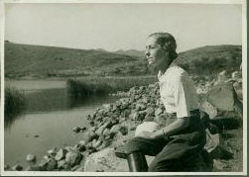
- Martin Rikli
Germany, 1898-1969
[Portrait of a European woman on a wooden boat], ca 1935-1936
Photograph from Album 2
8.5 x 10.5cm(original)
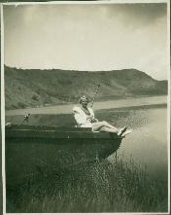
- Martin Rikli
Germany, 1898-1969
[European woman in her bathing suit poses for a portrait in the grass], ca 1935-1936
Photograph from Album 2
11.25 x 8.25cm(original)
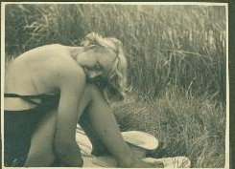
- Martin Rikli
Germany, 1898-1969
[European man and woman hold a monkey while an Ethiopian holds the leashes], ca 1935-1936
Photograph from Album 2
8.75 x 11.75cm(original)
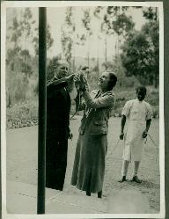
- Martin Rikli
Germany, 1898-1969
[Frau Hilde Johanssen in fur collar with monkeys on leashes], ca 1935-1936
Photograph from Album 2
11.5 x 8.5cm(original)
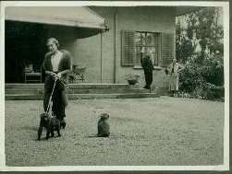
- Martin Rikli
Germany, 1898-1969
[Monkey on a chain with a youngster in her arms], ca 1935-1936
Photograph from Album 2
7.5 x 10cm(original)
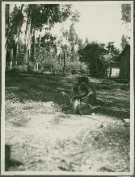
- Martin Rikli
Germany, 1898-1969
[An Ethiopian man holds a lion cub], ca 1935-1936
Photograph from Album 2
8.5 x 11.5cm(original)
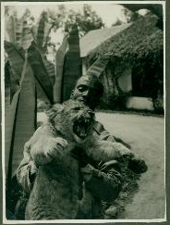
- Martin Rikli
Germany, 1898-1969
[Ethiopian man in tribal headdress], ca 1935-1936
Photograph from Album 2
9 x 11.5cm(original)
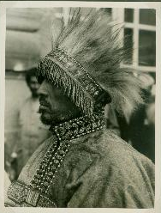
- Martin Rikli
Germany, 1898-1969
[Six Ethiopian women dance on a rural path], ca 1935-1936
Photograph from Album 2
7.5 x 5.5cm(original)
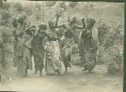
- Martin Rikli
Germany, 1898-1969
[Posed topless portrait of an Ethiopian woman], ca 1935-1936
Photograph from Album 2
5.5 x 8cm(original)
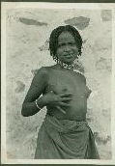
- Martin Rikli
Germany, 1898-1969
[Posed nude portrait of an Ethiopian woman; she wears a beaded necklace], ca 1935-1936
Photograph from Album 2
8.25 x 6cm(original)
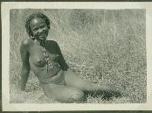
- Martin Rikli
Germany, 1898-1969
[Posed topless portrait of an Ethiopian woman], ca 1935-1936
Photograph from Album 2
4.75 x 7.25cm(original)
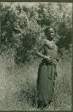
- Martin Rikli
Germany, 1898-1969
[Three servers in turbans and white gloves offer alcoholic beverages], ca 1935-1936
Photograph from Album 3
11.75 x 8.25cm(original)
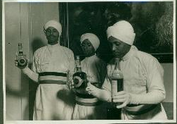
- Martin Rikli
Germany, 1898-1969
[European civilian men line up outside a villa flying a Nazi Luftwaffe flag], ca 1935-1936
Photograph from Album 3
11.25 x 8.5cm(original)
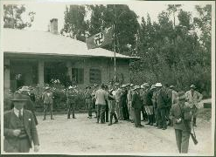
- Martin Rikli
Germany, 1898-1969
[Ethiopian man in uniform stands at the window of a train car and displays the front page of a German newspaper: Hitler is in the cover photo], ca 1935-1936
Photograph from Album 2
11.5 x 8.5cm(original)
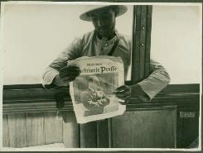
- Martin Rikli
Germany, 1898-1969
[European man appears to survey the fire damage in a business district of Addis Ababa], ca 1935-1936
Photograph from Album 3
11.25 x 8.25cm(original)
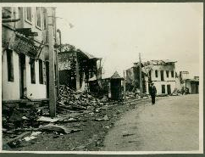
- Martin Rikli
Germany, 1898-1969
[Street view of Addis Ababa after Italian invasion; signs of looting in the streets], ca 1935-1936
Photograph from Album 3
11.5 x 8.5cm(original)
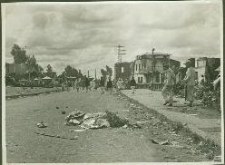
- Martin Rikli
Germany, 1898-1969
[Street view of business district in Addis Ababa shows burned buildings and trash in the street], ca 1935-1936
Photograph from Album 3
11.5 x 8cm(original)
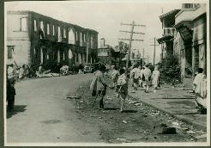
- Martin Rikli
Germany, 1898-1969
[A European man and woman stand in pith helmets while Ethiopians look on in the background], ca 1935-1936
Photograph from Album 2
11.75 x 8.5cm(original)
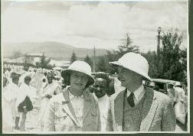
- Martin Rikli
Germany, 1898-1969
[An uncovered corpse], ca 1935-1936
Photograph from Album 3
17.25 x 11.5cm(original)
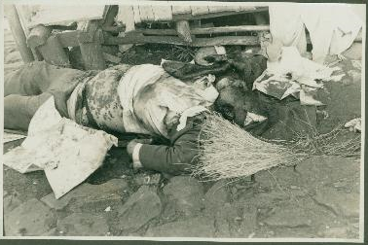
- Martin Rikli
Germany, 1898-1969
[Italian notice posted for public viewing], ca 1935-1936
Photograph from Album 3
11.5 x 17.25 cm(original)
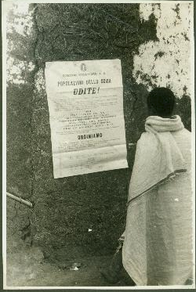

- Martin Rikli
Germany, 1898-1969
[A corpse in the street is partly covered with paper and foliage], ca 1935-1936
Photograph from Album 3
11.5 x 8.5cm(original)
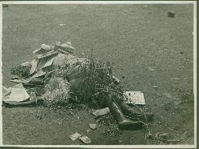

- Martin Rikli
Germany, 1898-1969
[Album 1 of 4] “Abessinien 1935-1936”, ca 1935-1936
Photo Album
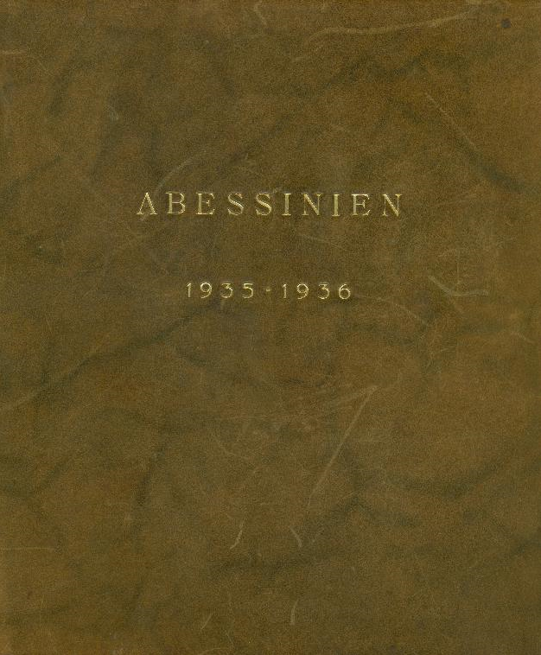

- Martin Rikli
Germany, 1898-1969
[Album 2 of 4] “Abessinien 1935-1936”, ca 1935-1936
Photo Album
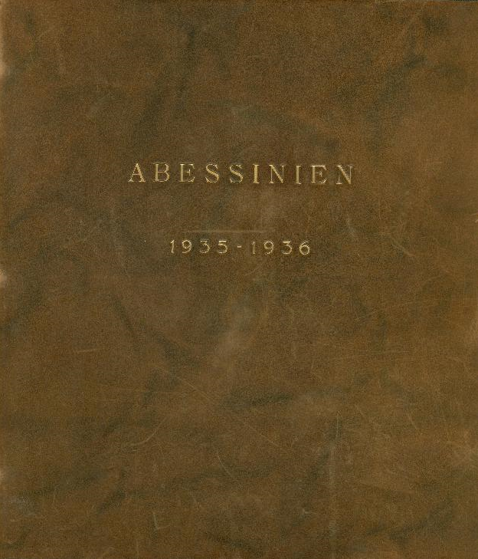

- Martin Rikli
Germany, 1898-1969
[Album 3 of 4] “Abessinien 1935-1936”, ca 1935-1936
Photo Album
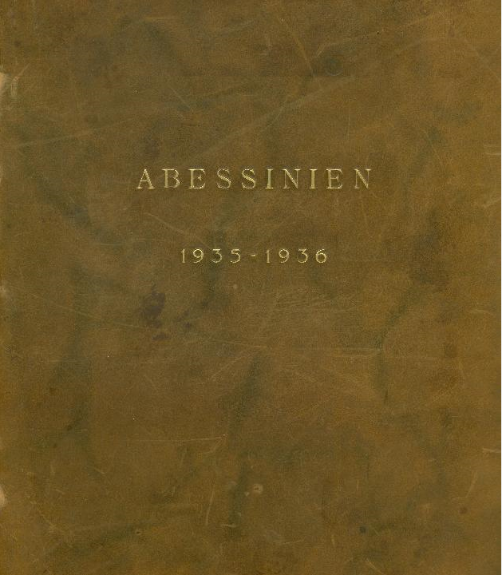

- Martin Rikli
Germany, 1898-1969
[Album 4 of 4] “Anmerkungen zur Lichtbildsammlung” (Notes for Photo Collection), ca 1935-1936
Photo Album
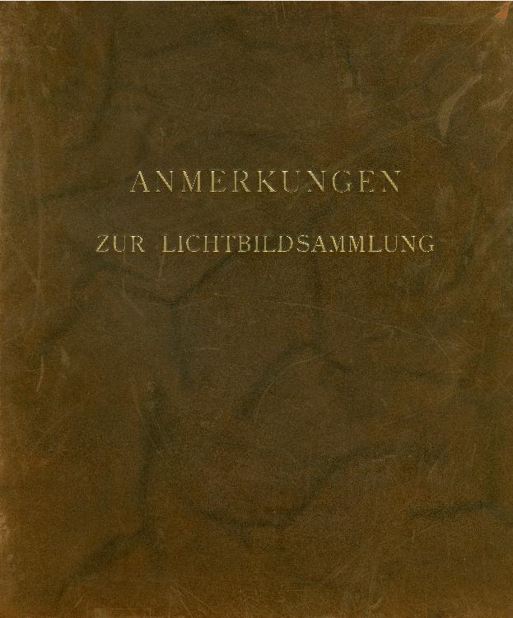

- Martin Rikli
Germany, 1898-1969
“Letter to Written by Martin Rikli from Addis Ababa” ca 1935-1936
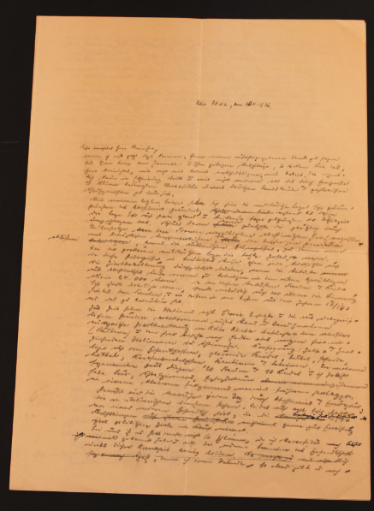

- Hermann Weist, author
Germany, ca. 1930s
“Abessinien von Heute – Blickpuenkt der Welt”
Film Program for Rikli Documentary, cover
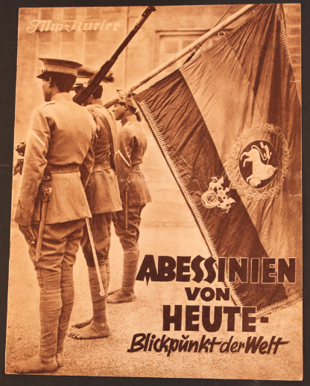

- Hermann Weist, author
Germany, ca. 1930s
“Abessinien von Heute – Blickpuenkt der Welt”
Film Program for Rikli Documentary, pages 1 and 2
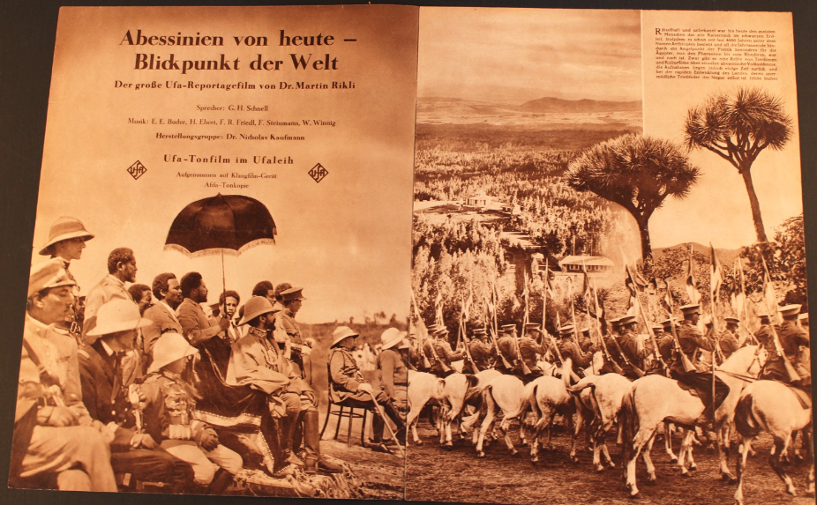

- Hermann Weist, author
Germany, ca. 1930s
“Abessinien von Heute – Blickpuenkt der Welt”
Film Program for Rikli Documentary, pages 3 and 4
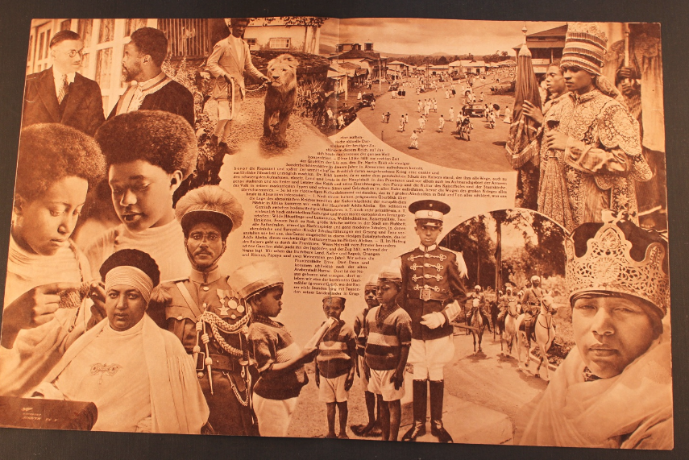

- Hermann Weist, author
Germany, ca. 1930s
“Abessinien von Heute – Blickpuenkt der Welt”
Film Program for Rikli Documentary, pages 5 and 6
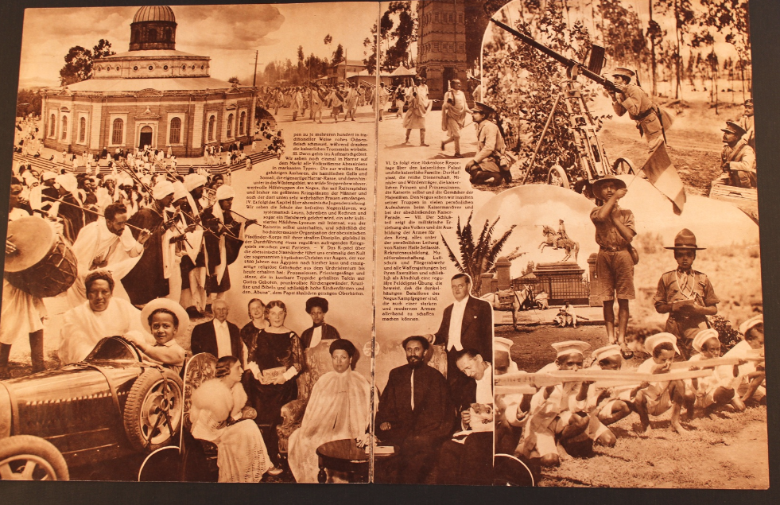

- Hermann Weist, author
Germany, ca. 1930s
“Abessinien von Heute – Blickpuenkt der Welt”
Film Program for Rikli Documentary, back cover
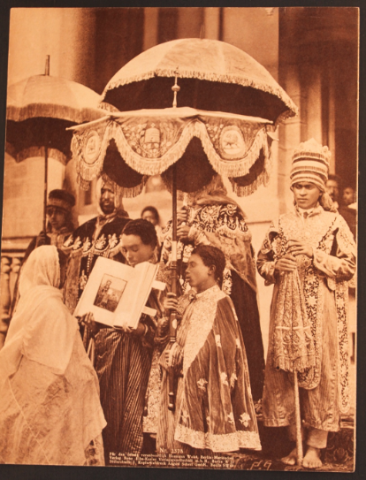

- Berliner Illustrierte Nachtausgabe
Saturday, August 31, 1935
“Abschiedsaudiez bei Kaiser Haile Selassie” (Parting audience for Emperor Haile Selassie)
Newspaper article
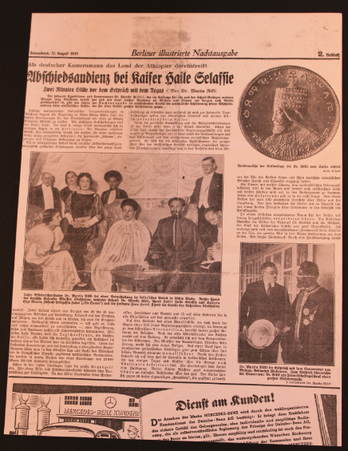

- Unknown Publishers
ca. 1935-1936
German Newspaper Clippings
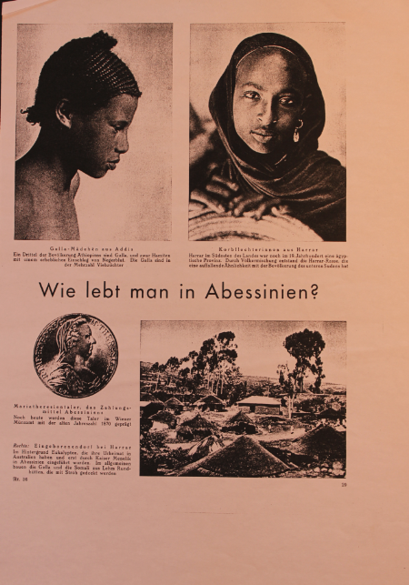 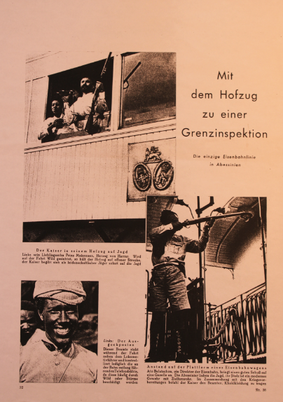 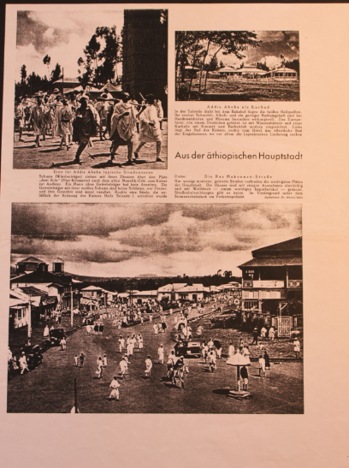

- Edizioni Mantovani
Colonie Dell’Africa Orientale Italiana E Abissinia
Italy, ca 1937
50 x 70 cm
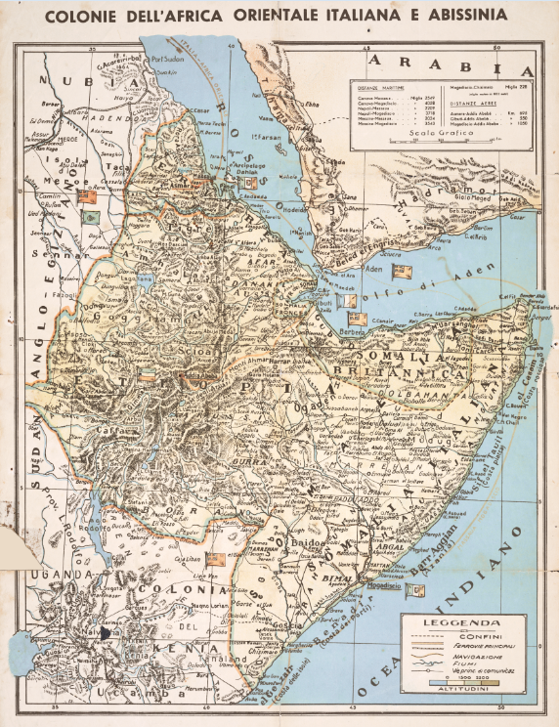

- Artist Unknown
Photo of Dr. Martin Rikli
ca. 1930
3:4 ratio measurements
