James Haskins Exhibit Layout – Spring 2008
Smathers Library 2nd Floor Exhibit Area
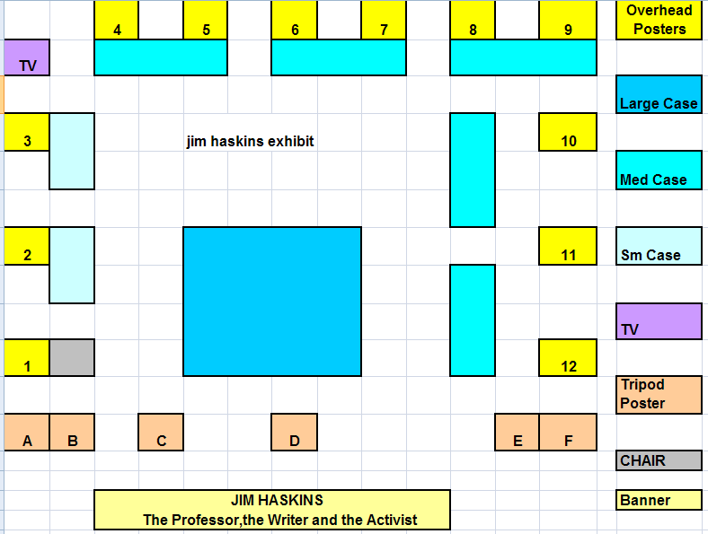

Details of the above layout (color-coded and numbered)
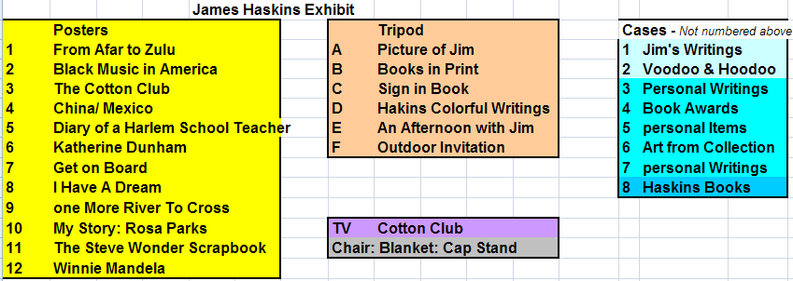
Contents lists below correspond to the numbered Cases listed above (far right)
1 | Blacks in Whaling
 | Civil War Times
 | Blacks in Military
 | Mansa Musa
 | Blacks in Gold Rush
 | Amazing Grace
 | Post office-Gainesville-Photo- Frame
 | City of Gainesville proclamation- Frame
 | Old Film Spilter
2 | Witchcraft, Mysticism & Magic
 | Wvoodoo and Hoodoo
 | Moaning Bones & Cover
 | Branch, leaves, cloth, glasses
3 | Cotton Club
 | Jazz Age
 | Bricktop
 | Ella Fitzgerald
 | 78 LP- Rchoes
 | 78 LP- Ella Fitzgerald
 | 78 LP- Ella Fitzgerald
 | Cotton Club- L500
 | Cotton Club- Lideo cover
 | Bojangles- Video
 | Ash Tray
 | Audio Tape-
 | Zora Neal Hurston with J. Haskins
 | Frames: 1, 2 , 3
4 | 1. 1994- National Council
 | 2. 1998- Proclamation
 | 3. Key to City: glass
 | 4. 1998- Award
 | 5. Bayard Austin- Book
 | 6. Coretta Scott King Award
 | 7. Small Glass plague
 | 8. Large Glass plague
 | 9. California Library Association
 | 10. Alabama Library Association
 | 11. Carter Woodson Award
5 | Bound for America (3)
 | River to Cross
 | Tie
 | Eye Glasses
 | Briefcase
 | Jacket
 | Marbles
 | 1982 World's Fair
 | Pencil Holder
6 | Hands- Frame
 | SIX- Frame
 | People- Frame
 | Face- Frame
 | Mask (2)
 | Container, Wood Box small
 | One Loose, One heart- Book
 | Black New York- Book
 | Mr. Bojaneles
7 | Typewriter
 | pencils
 | legal Pads
 | Letter
 | 1997 Appointment Book
 | 1997 Appointment Book
 | New York Library- Frame
 | Diary
 | Happy to be Happy & Cover- Book
 | Letter in Typewriter
8-a | New York Cotton Club: PB
 | Stevie Wonder Scrapbook
 | Something About the Author
 | Were Wolves
 | Teen-Age Alcoholism
 | Bill Cosby
 | Fighting Shirley Chisholm
 | Thurgood Marshall
 | Voodoo & Hoodoo
 | Hal Jackson
 | Black New York
 | Hamp
 | Lew Alcindor to Kareem Abdul Jabbar
 | Lew Alcindor to Kareem Abdul Jabbar
 | Scotboro Boys
 | Lena
 | Colin powell
 | Conjure Times
 | Diary of a Harlem School Teacher
 | Historic Black South
 | Break Dancing
 | African American Entrepreneurs
 | African American Military Heros
 | From Afar to Zulu
 | Black Music in America
 | Black Manifesto for Education
 | Barbara Jordan
 | Black Eagles
 | Bob McAdoo Superstar
 | Babe Ruth and Hank Aaron
 | Lena Horne
 | The Headless Haunt
 | The Great American Crazies
 | Diary of a Harlem Schoolteacher
 | The Quiet Revolution
 | Christopher Columbus
 | The Creoles of Color of New Orleans
 | A New kind of Joy
8-b | Count Your Way Through Africa
 | Count Your Way Through Arab World
 | Count Your Way Through Canada
 | Count Your Way Through Russia
 | Count Your Way Through Germany
 | Count Your Way Through Greece
 | Count Your Way Through India
 | Count Your Way Through Ireland
 | Count Your Way Through China
 | Count Your Way Through Mexico
 | Count Your Way Through Israel
 | Count Your Way Through Brazil
 | Count Your Way Through France
 | Count Your Way Through Italy
 | Count Your Way Through Japan
 | Count Your Way Through Korea
 | Catherine Dunham
 | Revolutionaries: Agent of Change
 | The Life and Death of Martin L. King
 | Jokes from Black Folks
 | Black Authors and Illustrators
 | Toni Morrison
 | Space Challenger
 | Black Theater in America
 | Mabel Mercer
 | James Van DerZee
 | Black Divorce in America
 | I Am Someone
 | One Nation Under Groove
 | One Love, One Heart
 | Magic Johnson
 | Toni Morrison
 | Mr. Bonjangles
 | Profiles in Black Power
 | Pinckney Benton Stewart Pinchback
 | India Under Indira and Rajiv Gandhi
 | Ralph Bunche
 | Winnie Mandela
 | The Long Struggles
 | Farrakhan and the Nation of Islam
 | Shirley Temple Black
 | Power to the People
8-c | Scatman
 | Stevie Wonder
 | Separate but Equal
 | Get on Board
 | Resistance: Profiles in Nonviolence
 | Pele
 | Adam Clayton Owell
 | Sugar Ray Leonard
 | About Michael Jackson
 | Always Movin' On
 | Andrew Young
 | Against All Opposition
 | The Cotton Club
 | The Consumer Movement
 | Cecil Poole
 | Nat King Cole
 | Rosa parks
 | Sports Great; Magic Johnson
 | The Cuban Boat People
 | Doctor J
 | Spike Lee
 | Scott Joplin
 | George McGinnis
 | One More River to Cross
 | The War and the Protest
 | Who Are the Handicapped
 | Your Rights Past and present
 | Witchcraft, Mysticism and Magic
 | Street Gangs
 | The 60's Reader
 | Black, Blue and Gray
 | The Harlem Renaissance
 | The Geography of Hope
 | Outward Dreams
 | Donna Summer
 | Magic
 | The Methodists
 | Moaning Bones
 | Corazon Aquino Leader: Philippines
 | Double Dutch
8-d | Lift Every Voice
 | The Filipino Nation: Vol. 1-3
 | The March on Washington
 | He Will Lift Up His head
 | Deep Like The Rivers
 | Gambling Who really Wins
 | The Statue of Liberty
 | Amazing Grace
 | The Day That Sumter Was Fired On
 | Book Links
 | Distinguished African American Political
 | Vietnamese Boat People
 | The Guardian Angels
 | A Piece of the Power
 | Real Estate Careers
 | Richard Pryor
 | I'm Gonna Make You Love Me
 | Freedom Rides
 | Keeping the Faith
 | Bound for America
 | African Beginnings
 | Buiding a New Land
 | I Have A Dream
 | Champion: Muhammad Ali
 | Snow Sculpture and Ice Carving
 | Voices and Visions
 | Carter G. Woodson
 | The Day That MLK, Jr. was Shot
 | Black Stars of the Civil Rights Movement
 | Black Stars of the Civil War
 | Black Stars of the Colonial and Revolut
 | Black Stars of the Harlem Renaissance
 | The Picture Life of Malcolm X
 | Don' say no mo' wid yo' mouf dan yo'
 | Jobs in Business and Office
 | Leaders of the Middle East
 | Queen of the Blues

