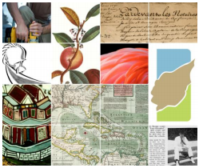
DIGITAL LIBRARY OF THE CARIBBEAN | FACT SHEET

Mission
dLOC's diverse partners serve an international community of scholars, students, and citizens by working together to preserve and to provide enhanced electronic access to cultural, historical, legal, governmental, and research materials in a common web space with a multilingual interface.

Access to Caribbean Resources
The amount of open access content available through dLOC surpasses many commercial Caribbean collections and includes newspapers, official documents, ecological and economic data, maps, histories, travel accounts, literature, poetry, musical expressions, and artifacts. dLOC now provides access to 2,783,922 pages of content related to the Caribbean. dLOC registered a cumulative total of 59,990,902 views from April 2006-August 2015.
All content available openly: www.dloc.com

The freely available dLOC Toolkit, training support and continued improvement of the technology with faceted and geographic searching and new user features are keys to the project’s success. Local funding supports the costs of digitization for dLOC which will enable the project to continue to grow. The more than forty partners demonstrate the value of dLOC’s content for technology exchange.
Software openly available here: http://dloc.com/software & http://sobekrepository.org

Digitization training program for international partners
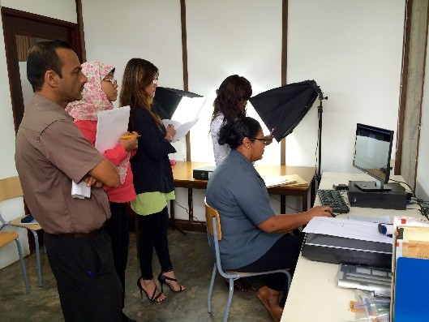
Since 2005, dLOC has delivered on-site training to more than 390 people during 27 in-country trainings. Through training at the Caribbean Library Association (ACURIL) conference, dLOC reached hundreds of people through workshops and 600 with poster presentations. The trilingual digitization training manual, online videos and other supports provide partners with the skills to build local digitization programs. New opportunities for training continue to develop.
Details and training materials: http://dloc.com/dloc1/training

Caribbean Studies K-12 Educational Outreach
Through collaboration with the Title VI National Resource Centers for Latin American Studies at Florida International University and the University of Florida, dLOC provides teacher training workshops, presentations and booths at local and national conferences and a nation-wide lesson plan competition that have reached thousands of K-12 teachers. The Teaching Guides and Materials collection now hosts 27, 396 titles with over 336, 056 views. dLOC continues to work with teachers and seek contributions to encourage the study of the Caribbean at the K-12 level.
Details: http://dloc.com/teach

dLOC Seed Grant Program
In 2014, the first round of dLOC Seed Grant Program awarded five partners with a total of $17,000 including support for training, equipment and staffing. The dLOC Seed Grant Program provides initial funding for activities that build local programs and support online open access digital resources for researchers, students, and the general public by supporting contributions to the dLOC repository.
Details: http://www.dloc.com/l/AA00027510/00001

Recent Online Exhibits
The online exhibition About Face: Revisiting Jamaica's first exhibition in Europe reconsiders that exhibition by re-presenting its art and related materials online. The exhibit includes over forty of the original works of art by such noted artists as Edna Manley, Karl Parboosingh, and Barrington Watson, as well as original news articles about the exhibition and a study of Jamaican perception and pop culture in the early 1960s.

Details: http://dloc.com/l/exhibits/aboutface

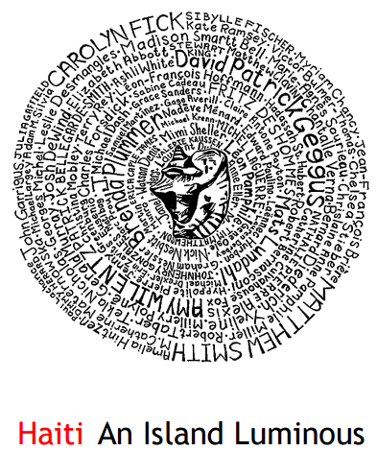
Haiti, An Island Luminous will pair expert commentary and original documents to introduce users to five hundred years of Haitian history. The exhibit promotes an understanding of the complexity of Haitian history through increased access to research resources with contributions from current scholars and students, as well as excerpts from past publications, and direct links providing free access to books, manuscripts and newspapers.
Details: http://dloc.com/exhibits/islandluminous

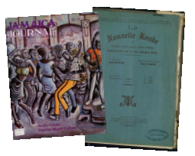
Previous Research Projects
In October, 2010, dLOC received $440,000 in funding over four years from the U.S. Department of Education TICFIA program to develop a collaborative online collection of historical and contemporary newspapers and literary journals. The Caribbean Newspaper Digital Library has already received significant praise from scholars. It is through access to these rare resources that new and innovative research initiatives can begin.
Details: http://dloc.com/cndl
In response to the earthquake in Haiti on January 12, 2010, dLOC established the Protecting Haitian Patrimony Initiative to support recovery and preservation projects in Haiti. PHPI has provided support valued at $50,000 for the libraries to secure their collections and initiated a collaborative online exhibit with top scholars on Haiti’s history.
Details: http://dloc.com/l/info/haitianlibhelp
Building upon the strength of dLOC’s partnerships, Florida International University’s Strengthening Caribbean Research through Technology project, funded at $48,000 over 3 years, will provide faculty and students with the tools to incorporate dLOC sources from the Caribbean into teaching and research.
Details: http://dloc.com/about

Sustainability and Governance
The governance structures of dLOC ensure the project’s future. The Executive Board determines policy-making, planning and fundraising efforts while the Academic Advisory Board is an active, guiding force that bridges dLOC with broader academic communities.
Details: http://www.dloc.com/l/info/bylaw

