Ana(b)log: A Hyperlocal Blog for Indie Music Journalism

by Robert Hilson

Project in Lieu of Thesis

Spring 2011

Anablogmusic.com

Overview
The purpose of this project was to develop a hyperlocal music criticism blog covering indie music in Gainesville, FL.
Over the course of six and a half months, from the end of August 2010 to the middle of March 2011, Ana(b)log (Anablogmusic.com) reported on Gainesville’s artists, venues, industry professionals and newsworthy occurrences through text, video, audio, photography, podcasting and local internet radio in order to cultivate an influential online presence, establish a grassroots community of users, and supplement traditional local media.
An average of two to three posts per week were published on Ana(b)log and linked via social media such as Facebook, Twitter, YouTube, SoundCloud and Flickr. Keywords for search engine optimization were used to make the blog available for those searching via search engines.
The blog was self-hosted and maintained on DreamHost servers at WordPress.org. The completed project aims to demonstrate the decisions made during a blogger’s journey starting a hyperlocal blog

The Uses and Gratifications of Music Blogs
It was no doubt indicative of the state of music criticism in 2010, and probably that of print journalism as a whole, that a ranking from the indie sphere’s Alpha Voice, Pitchfork.com, was worth far more than stacks of newspaper reviews. Quantifying the value of a positive Pitchfork review to an aspiring young band – any band, for that matter – was perhaps only possible as word-of-mouth and blogosphere hype as metrics. A zero to 10 numeric rating affected the fate of an artist’s popularity. The online revolution in music criticism confounded at times, but, if anything, it became increasingly unmistakable that Pitchfork, an online review ezine at http://pitchfork.com/, and its followers – both ardent readers and upstart outlets taking cues – did things differently.
What was once founder Ryan Shreiber’s post-high school web project was some 15 years later a taste-making juggernaut: simultaneously the miles-ahead leader in snarky blog commentary and, more pertinently to the following discussion, the preeminent voice in pop music journalism, online or otherwise. As of late 2010, Pitchfork tallied upward of 30 million visits per month (Caramanica, 2010). It dictated artists’ publicity in much of the blogosphere. It carried a disproportionately large weight on review aggregators like Metacritic.com. It spawned a three-day, 40-plus band music festival and spun off affiliated sites dedicated to covering flourishing micro-genres under the mothership’s banner. Pitchfork was, in short, a monster of cultural significance: the eight-ton opinion in the room.
The site’s rise to prominence, hegemony some would say, came in the late 2000s – a time when the traditional music journalism establishment was struggling to adapt to a rapidly shifting media landscape. Rolling Stone no longer published in its once-iconic “wideload” format; Robert Christgau reviews no longer ran in the Village Voice; Spin Magazine no longer showed an interest in anything other than being another Blender.
In an age of ironic hipsterdom when terms like “relevant” took on an entirely ambiguous meaning to people in the know, it was precisely the traditional idea of relevance with which the older publications established in the 1960s, 70s and 80s struggled. Pitchfork lead the avant-charge to do music criticism uniquely – uniquely as in the Twitter handle “Discographies” that reviewed entire artist catalogues in 144 impossibly witty characters; uniquely as in Markprindle.com posting a bi-weekly handful of vulgar, non sequitur-laced – incredibly influential – critical assessments.
A myriad of unavoidable questions may have piqued the interest of those uninitiated to this relatively new wave of music journalism. Did it even make sense? Did the sea change in criticism abide by rhyme or reason? Is its future form predictable? Why did audiences flock to online publications such as Pitchfork so fervently?
To the first question – did the Pitchfork phenomenon make sense – the answer was: maybe. Could traditional communications theories adequately explain such an innovative and rapidly shifting development? The speed of technological advancement challenged those trying to makes sense of easily dated research data. It was harder than ever, from a research standpoint, to keep pace with an incessantly evolving digital environment.
Mark Zuckerberg coded the Facebook prototype in a day.
Using the theory of uses and gratifications to examine why and how audiences consume online media may assist indie music bloggers in developing a more complete product for their audiences.

Literature
Uses and gratifications, defined by Katz, Gurevitch and Haas (1973) as an approach “studying the gratifications which attract and hold audiences to the kinds of media and the types of content which satisfy their social and psychological needs,” (p. 164) gained a renewed traction since the advent of the Internet and its subsequent adoption as a mass medium. In his historical overview of the theory, Ruggiero (2000) noted that the popular emergence of telecommunication technologies reinvigorated the uses and gratifications field with three new attributes specific to “new media” – those of interactivity, demassification and asynchroneity. The “ability of the media user to select from a wide menu” (Ruggiero, 2000, p. 16) and the “concept that messages may be staggered in time,” (Ruggiero, 2000, p. 16) respectively, demassification and asynchroneity, combined with newly available interactivity, pushed researchers to explore whether these evolved media forms afforded the same motivational and gratification-fulfilling opportunities as traditional ones.
As much as uses and gratifications theory evolved in its roughly 60 years of existence, the central premise delineated in its seminal espousal applied to 2011’s media environment with only slight modifications.
Herta Herzog (1954) was among the first to suggest audiences use media to satisfy personal gratifications with her landmark analysis of 100 radio soap opera listeners more than a half-century ago. As outdated as such a study may seem in terms of content and medium examined, its central proposal that media offered the potential for information and problem-solving advice, emotional release, and vicarious experience resonated with modern theoretical rationale at the dawn of the new millennium.
Katz (1959) probed the uses of local newspapers and advanced uses and gratifications theory to a place not far removed from its current state. Indeed, Katz’s assertion that newspaper audiences are motivated by entertainment, escape, information gathering, prestige and the pressure of social stigma potentially covered much the same gratifications as Pitchfork.
The uses and gratifications studies (Katz, Blumler, & Gurevitch, 1974; Katz, Gurevitch, & Haas, 1973; McQuail, Blumler, & Brown, 1972) classified user gratifications into social and information-gathering categories. Both classifications applied to the new media of 2011.
Katz, Gurevitch and Haas (1973) condensed 35 different potential media uses into five thematic categories: those satisfying cognitive needs; affective and emotion-based needs; “personal integrative,” or identity needs; social integrative needs; and tension release needs. These typologies were similar to Charney and Greenberg’s (as cited in Li, 2005, p. 14) Internet-based dimensions of information, good feelings, peer identity, communication and diversion-entertainment. Eastin and LaRose (2003) likewise fleshed out the “personal integrative” dimension by linking Internet consumption with personal status. Furthermore, Katz et al.’s “tension release” dimension translated to the Internet as flaming, in which users “criticize someone personally or… attack their utterances in an overly harsh, disproportionate fashion” (King, 2001, p. 416).
Early uses and gratifications studies also predicted the emergence of media-induced communities, defined as “a set of people who have diverse backgrounds and are linked by social ties, share common values, and even are involved in a joint action in geographical locations or settings” (Muniz & O’Guinn, as cited in Shen & Chiou, 2009, p. 394). For example, Katz’s (1959) secondary findings identified a phenomenon in which children well connected with peer groups tend to appropriate popular adventure stories encountered in the media to play group games.
Many researchers cited similar behaviors as those furthering the spread of social media (Bonds-Raacke & Raacke, 2010; Li, 2005; Schmidt, 2007; Shao, 2009; Shen & Chiou, 2009). The interactive video hegemon YouTube, for example, showed an evolutionary progression to the “adventure story” community development described by Katz (1959). Guosong Shao (2009) concluded in a recent study of user-generated social media that, though sites like YouTube primarily appealed to users need for entertainment, they also spawned virtual communities through forums for text interaction and video responses to initial videos (p. 18-19). Online communities seemed to possess the capacity to produce their own “adventure stories” from which to develop forums for group interaction. Moreover, Shao found audiences also create user-generated media as manifestations of self-expression and personal identity. This production of media, he maintained, may have stemmed from prior consumption of others’ user-generated media, suggesting the existence of organic, self-propagating communities primarily sustained by audiences’ need to interact parasocially (p. 18-19). Shirky (2008) went even further, arguing that the types of organizations described by Shao could not exist without the market-neutralizing abilities of social media applications like Flickr, Wikipedia and WordPress.
Similarly, Schmidt (2007) argued in her construction of an analytical framework for blog users that this medium often spawned and sustained its own communities, and more, often existed as the basis for personal identification within a subculture. Stafford, Stafford and Schkade (2004) described the Internet as a social environment and distinguished interpersonal motivations from long-established uses based on process and content gratifications. David Schwartz (2009) further elaborated on the formation of blogging communities by tying interaction with online peer groups to expressions of personal identity. In addition, he found that readers’ willingness to interact through blogs was directly correlated to a willingness to disclose personal information, how much personal information the blogger disclosed, and perception of self-efficacy within the community.
Likewise, Chung-Chi Shen and Jyh-Shen Chiou (2009) proposed that when readers identify with a blogging community, their ability to bond with other users, knowledge of the community and other social investment capital increased. Readers, in turn, were more likely to continue participating in the community and reading the blog. Describing this cyclical relationship, the researchers concluded, “higher community identification intensified greater consumer’s willingness to invest in specific assets on a blogging community, which in turn affects the consumer’s attitude and intention toward using the blogging community” (p. 403). Lee, Im and Taylor (2008) observed that blogger-reader recipricosity and smaller community sizes generally promoted identity disclosure and community participation, but that the latter findings didn’t necessarily apply to the Internet. As with the Schmidt (2007) and Schwartz (2009) studies, these conclusions addressed blog users’ need for gratification-fulfilling social connectedness and development of personal identity. They also suggested that bloggers can facilitate community-building by reducing impediments to user participation and investment.
One would’ve expected to find vibrantly interacting communities springing up through these blogging outlets because users visited them for social interaction. Through an online survey of 250 MP3 blog users, O’Donnell and McClung (2008) attempted to measure the rationale behind frequenting music blogs. The researchers examined a socially-oriented motivation for using MP3 blogs (where music could be downloaded in the MP3 format) – one that supplemented more pragmatic reasons like building music libraries, acquiring free music, and learning about bands (O’Donnell & McClung, 2008). What was surprising since it’s difficult to quantify was the study’s “be in on the buzz” social dimension: a measure describing audiences’ desire to participate in the grassroots-level excitement around new bands that only existed, at first, among smaller, alternative outlets. Also notable was the idea that O’Donnell and McClung (2008) distinguished the “buzz” factor from that of “learning about new music,” defining the former as fulfilling a social and psychological need to “listen to bands other people are talking about” (p. 17). The study was similar to McCain, Morris and Green’s “what’s new/cool” gratification (as cited in Song, Larose, Eastin, & Lin, 2004, p. 391). McCain et al.’s finding was significant because it distinguished the gratifications offered by the blogosphere from those conferred in traditional media – specifically, diversion, knowledge acquisition, identity, and surveillance (McQuail, Blumler, & Brown, 1972).
Blogger Chris Baltimore (2009) of Reuters’ “Fan Fare” wrote a post analyzing how music blogs differentiated themselves from newspapers and traditional criticism outlets like “Rolling Stone.” Extending O’Donnell and McClung’s (2008) “buzz” logic, Baltimore wrote that music fans, especially local and independent music enthusiasts, turned to the blogosphere for its taste-making expertise. He argued bloggers had in some ways replaced both local print publications and the advice of record store clerks as they utilized “one of the last really enthusiastic mediums” left (Baltimore, 2009, para. 9). Blogs also differed in their tone, he wrote. While mainstream critics, for instance, may have made careers from biting reviews, bloggers – many strapped for time and money – mostly only wrote about the bands they enjoyed. This “labor of love” mentality offered readers a more positive, less cynical experience and may have played a role in influencing user motivations. In addition, Baltimore further distanced music blogs like “Aquariam Drunkard” (Aquariumdrunkard.com) and “Done Waiting” (Donewaiting.com) from newspapers in their ability to both unearth good, local bands and generate word-of-mouth publicity.
For users, word-of-mouth fulfilled a need that was similar to both Bonds-Raacke and Raacke’s (2010) social media-induced “connection” dimension and that of “buzz” – namely, being able to talk about bands that “cool” people listened to (O’Donnell & McClung, 2008). But given the rapid incorporation of social media within the blogosphere, word-of-mouth may have also testified to users’ longing to interact with artists, if only on a meta-level.
Of course, a willingness to interact with the artists themselves didn’t necessarily trump user motivations to develop emotional relationships with the bloggers. Indeed, that bloggers’ had the ability through voice and personality to form bonds with users (and, reciprocally, to be the object of affection) harkened back to the golden era of 6 o’clock news. In an analysis of television audiences, Levy (1978) found that watchers returned to the same news programming because of bonds formed with certain anchors, who in turn, made sense of potentially confounding information. Perse (1990), measuring the effects of emotional and cognitive involvement on information holding and parasocial interaction, identified similar behavior in her study of viewer interaction with local news television broadcasts. Like Levy, she found audiences actually developed “pseudo-friendships” (p. 21) with media personalities based on perceived similarities, liking and attraction – emotional attachments which, in turn, became motivations for repeated media use. Perse concluded “only feeling happy while watching the news was associated with parasocial interaction; feeling sad or angry were unrelated” (p.31).
Though such findings may have varied given the Internet’s at times negative culture (King, 2001), the application of electronic media studies to the blogosphere was clear: audiences’ development of highly personal, emotional and cognitive connections with bloggers potentially fostered increased blog use. Trammel and Keshelashvili (2005) argued as much in a study of “A-list” blogs. Sampling those with high readership and several incoming links, they argued that a blogger’s popularity was directly associated with high levels of personal disclosure and a high degree of “self awareness of purported influence” (p. 15). In addition, A-list bloggers embraced their identity as an alternative to mainstream online media. One prominent writer wrote, “As a blogger and not an independent peer reviewed journalist, I am able to write about what I had for lunch or my broken coffee pot without feeling as if I’m breaking some journalistic standard” (Trammel & Keshelashvili, 2005, p. 15).
When discussing the blogosphere, one would be remiss to overlook issues of perceived credibility. In light of the popularity of Pitchfork.com and other online music publications, a level of blogger or writer expertise may have factored into user motivations to read a given publication. Past research supports the need for perceived credibility.
Johnson and Kaye (2004), in a survey of 3,747 political blog readers, found a striking 73.6 percent of audiences rated the medium as either “moderately credible” or “very credible”, combined with only 3.5 percent who rated blogs as “not at all” or “not very credible” (p. 630). This perceived credibility stemmed from blogs’ independence from corporate interests, collaborative fact-checking, interest in tackling overlooked issues, and willingness to discuss sensitive topics (Johnson & Kaye, 2004). “Depth of information” was rated highest in terms of credibility attributes, but readers also judged blogs to be believable and fairly accurate as well (p. 630). Significant, too, was the idea that audiences considered blogger bias a core strength – one that factored into high credibility scores. “While fairness may be considered a hallmark of traditional journalism, bias is likely seen as a virtue by blog users,” the researchers wrote, adding, “Blog readers are seeking out information to support their views…” (Johnson & Kaye, 2004, p. 633).
Johnson and Kaye (2008), in a follow-up study, noted political blogs rated higher in credibility even than issue-oriented sites and candidate sites. Again, the authors cited a strong motivation to reinforce beliefs, stating, “Indeed, supporters of blogs perceive bias, along with insight and analysis, as strengths over traditional media” (Johnson & Kaye, 2008, p. 7). Interestingly, this finding was not found in earlier political medium uses and gratifications studies. Blumler and McQuail (1969), for instance, concluded that, although British television audiences turned to political programming to fulfill informational needs, they did not specifically tune into shows reinforcing existing beliefs. While blogs, specifically, rated high in users’ perceived credibility, other online media may have received more reader skepticism.
Chyi and Yang (2009) concluded readers actually considered online news publications inferior to their paper counterparts, despite their added functionality and convenience. These findings differentiated the blogosphere from traditional publications that had been merely duplicated on the Web. Namely, blogs did not have to contend with print counterparts and thus deal with the negative connotations associated with existing as a “knockoff of the real thing.” Chen and Corkindale (2008) argued, however, that reader trust and subjective norms – perceptions of other referent groups within the digital community – played an important part in adoption, a finding that presumably applied to blogs as well.
If audiences were indeed motivated to read the work of like-minded bloggers, such actions were perhaps driven by habitual behavior. Palmgreen, Wenner, and Rayburn (1981), in an analysis of the ritualistic consumption patterns of television news audiences, were among the first to point out that habit may actually trump the need-gratifying pull of certain media attributes. The study purported:
While in certain cases more specific perceptions of anchorperson, program format, and news quality may be more important, the discriminant analyses indicate that the perception of differential gratifications are at least as strongly related to viewing behavior as the more traditional measures of program attributes. (Palmgreen et al., 1981, p. 472)
Other studies have found the habit-forming consumption of traditional media to translate to the Internet (Milani, Osualdella, & Di Blasio, 2009; Perse & Dunn, as cited in Liu, Cheung, & Lee, 2010; Song, Larose, Eastin, & Lin, 2004). In some instances, usage once motivated by the conscious attempt to fulfill needs – specifically, virtual community, information seeking, aesthetic experience, monetary compensation, diversion, personal status, and relationship maintenance – gave way to subconscious, mildly addictive behavior (Song et al., 2004, p. 390). Diddi and Larose (2006) suggested, in the same vein, that online news media was among the most habit-forming, though perhaps for different reasons depending on the type of user. Diddi and Larose wrote:
News junkies may be understood to be those whose news consumption is prompted by a need to escape from their everyday routines, more along the lines of ritualistic media use… as opposed to the instrumental orientation of those with surveillance needs. (Diddi & Larose, 2006, Discussion section, para. 9)
As O’Donnell and McClung (2008) articulated in their study of MP3 blogs, aesthetic and practical attributes also influenced reader motivations to use a blog. Other “new” media research yielded similar results. Stafford, Kline, and Dimmick (1999) found conducting business to be among the most oft credited motivation schemas for using email. Chen and Corkindale (2008) connected simplicity of user interface and supplementary service quality to an adoption of online news services. Shao (2009) detected a correlation between user-generated media’s “ease of use” and “amount of user control” and its subsequent appeal to audiences. Zerba (2003) emphasized the importance of multimedia features in their perceived ability to contribute additional information from heavy news seekers. Conversely, from the blogger’s perspective, Li (2005) cited a motivation to improve writing skills.
Planning
Ana(b)log: Taking on Gainesville’s Hyperlocal Indie Music Scene
Ana(b)log was created and developed in the mold of other prominent local music blogs – like Brookynvegan.com, Seattlesubsonic.com, Soundonthesound.com, and Thebaybridged.com – and it emulated the style, format, themes and layouts related to hyperlocal music blogs. The audience for the blog ranged from 18 – 24 years of age, was transient, as college students often are, and was oriented toward both new media and a DIY lifestyle. I created Ana(b)log to speak to the readers of the Gainesville community.

Tone, Style and Writing on the Blog

My intentions with Ana(b)log, in keeping with journalistic norms, placed readers and prospective audiences at the fore. In other words, I wrote for my audience. As described in the literature review, researcher David Schwartz found a significant correlation between a blogger’s willingness to disclose personal information and the blogger’s subsequent ability to grow an online community. In turn, I both actively participated in the Gainesville music scene – by attending at least one local show per week, interviewing local acts, “friending” artists on Facebook and building a face-to-face rapport with many of Gainesville’s musicians – and injected my blog posts with detailed, first-person perspective. Returns showed this disclosure to be successful, as posts of a personal nature tended to receive the most reader comments and Facebook reposts. A Pseudo Kids album review written as first-person narrative, for example, was reposted 18 times. “Ana(b)log Crashes ‘Left of the Dial’”, a list of my favorite 2000s songs, was resposted eight times.

While the tone and writing of the site may not match the typical standards of newspaper journalism or AP style, the blog’s language was designed to appeal to an audience who appreciated humor, irony, sarcasm and irreverence sprinkled throughout its in-depth interviews and multimedia-based reporting. As evidenced by Pitchfork.com and other similar outlets, the indie music community circa 2010 preferred a style of writing that employed witty wordplay, cheeky send-up, insider references, and allusions to the broader popular music canon, and did not shy away from ridicule. However, given the close-knit dynamics of the Gainesville community and the relative obscurity of many of the local acts, I chose to cover only the artists I personally enjoyed. As I was once told by an entertainment editor at the Independent Florida Alligator, there is little value in skewering a musician no one’s heard of. This tactic of positive criticism also fell in line with journalist Chris Baltimore’s claim that blogging is largely a labor of love taken up by people who only have time to cover what they like.

With this is mind, I aimed to communicate in a style that both mirrored the irreverent, though critically insightful prose of leading internet publications like Pitchfork.com, Popmatters.com, Youaintnopicasso.com and Fluxblog.org, and spoke directly to a local readership whose inclinations weren’t necessarily served by typical newspaper commentary – which tended to favor long-form expository descriptions made largely obsolete by music’s free online accessibility.
The blog’s style of writing fell in line with the elite online publications mentioned above and, perhaps more pertinent to a discussion of traditional music criticism, “old” media stalwarts like Rolling Stone and Spin. Perhaps the biggest difference was that these outlets didn’t censor curse words with asterisks. I used Ana(b)log to dabble in creative writing, as evidenced by the post “Why is the bro from Dead To Me so angry, y’all?” – a tongue-in-cheek write-up that utilized poetic structure, text message-like shorthand, and perhaps best resembled the punctuation-free poetry of E.E. Cummings or, more probably, the blogger Carles of Hipsterrunnoff.com.

Content Management System

All of the content on the blog was not possible without a solid back-end content management system (CMS) by which to upload a wide variety of material. In the final week of August, I created the WordPress template that became Ana(b)log (though the site was originally entitled “University & Main”, signifying the cross-streets with several prominent local venues).

Having creating another blog, Sportscasualties.com, with a self-hosted domain at WordPress.org, I took advantage of WordPress’s user-friendly design options and one-click hosting setup with the Anablogmusic.com domain. I had also designed a syllabus for teaching blogging in 2010 as a project for a graduate class, “Developing Digital Online Media.” In designing this syllabus, I gave much thought to platform options, development of blogging strategies and how to teach others how to blog. WordPress was my recommended platform because of its advantages over other platforms, such as Blogger or Tumblr.

I purchased the domain name for $10 per year in August 2010 and bought web-hosting in July for 12 months through DreamHost, a $9.95 per month option that offered advanced spam guards, one-click installation and automatic hosting maintenance.

In total, the web space for Ana(b)log cost exactly $119.40 per year, a somewhat pricey option offset by the fact that DreamHost’s automated service and self-updating maintenance made it so bloggers needed only address web-hosting for matters of payment. In effect, Ana(b)log’s “back end” ran itself. According to the company’s official wiki, DreamHost backed up its clients’ sites using a combination of Apache, nginx, and lighttpd servers run by a Debian GNU/Linux operating system.

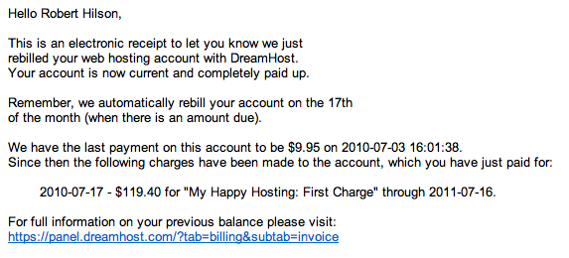Emailed receipt of web-hosting purchase from DreamHost

Aesthetically speaking, Ana(b)log’s design was engineered using a modified version of web designer Christian Proell’s “CP-Minimal” theme (version 1.1.1). Using CSS and HTML in WordPress.org’s “Editor” feature, I (a) took out the generic header in order to make room for the banner graphic created in Photoshop CS5 with Moderna font and custom shapes (b) selected an appropriate text package (a mix of Helvetica Neue, Liberation Sans, and Arial) (c) changed the color scheme and (d) inserted metadata using Google Adwords for keyword ideas that would better optimize the site for search engines. I learned to code in XHTML and CSS by taking MMC5015 Electronic Publishing with Professor David Carlson and was subsequently able to tweak the design template of the site, as well as individual posts in WordPress’s “HTML Editor”. Elizabeth Castro’s handbook “HTML, XHTML & CSS: Sixth Edition” was also helpful in this regard.

Widgets and Enhanced Functionality

Through a trial and error process of widget selection, I further honed the aesthetic and functional elements of the site to incorporate social media connectivity through Twitter and Facebook. Selected widgets also enhanced in-site navigation. OttoDestruct’s “Simple Twitter Connect – Base” widget, for instance, allowed me to automatically tweet published post links to Ana(b)log’s Twitter account in the form of a shortened URL. Steve Atty’s “WordBooker” widget provided the same service in Facebook when I added it to Anablogmusic.com in November.

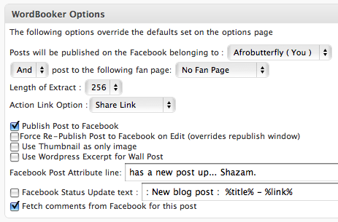

WordBooker widget publishing options for Anablogmusic.com

WordBooker automatically posted published blog posts to Facebook with a link that both provided a teaser excerpt and the ability to replicate comments on the Facebook link to the blog. Any comment made under the WordBooker Facebook link, then, would be automatically transcribed – with author data – to the blog.

While the generic WordPress “Tag Cloud” widget allowed readers a quick overview of Ana(b)log’s most blogged about topics and subjects, Kestas Mindziulis’s “Subscribe Widget” plugin generated a four-pronged subscription model allowing readers to subscribe to the blog via email, Facebook, Twitter, a comments RSS feed or a Feedburner RSS feed (though, as of March 20, 2011, no reader had used Feedburner to subscribe to Ana(b)log compared to 26 via the Facebook fan page and 70 via Twitter). Moreover, Ricardo Gonzalez’s “Twitter for WordPress” widget showed the tweets in the sidebar of Ana(b)log’s Twitter feed at http://twitter.com/anablogmusic with links back to the original tweets.

Two photography based plug-ins also added visual appeal to the otherwise stripped-down Ana(b)log aesthetic. The Cincopa video and photo download enabled me to include photo galleries into my posts by uploading pictures directly to Cincopa – thus saving the time and space of having to upload jpeg files to WordPress. The Cincopa plugin also transformed the photo galleries into slide shows upon clicking. “Defiance, Ohio At 8 Seconds: The Fest, Day 2” is an example of a post that put Cincopa to good use.
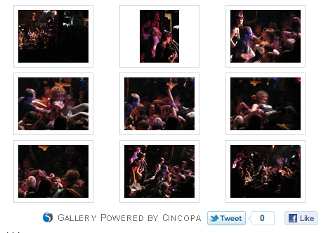
Example of embedded Cincopa photo gallery
Similarly, PlusNet’s “Flickr Thumbnail Photostream“ widget allowed me to create a photo feed on Anablogmusic.com of all the pictures I uploaded to my personal account at Flickr.com. Set to show six picture thumbnails at a time, the widget automatically generated a new thumbnail each time I uploaded a picture to Ana(b)log’s Flickr account. Should a reader click on any of the thumbnails, the widget produces a pop-out slideshow of all the photos uploaded to the Ana(b)log Flickr account.
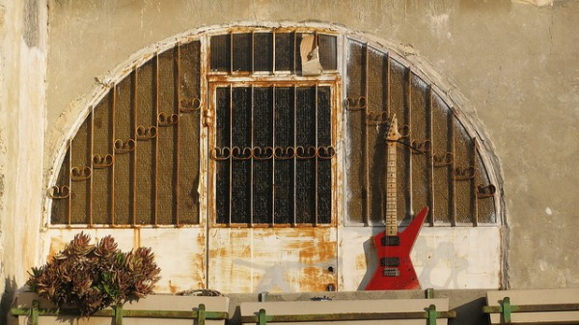
"Jerusalem Guitar": Example of photo uploaded to Ana(b)log Flickr Account
Blog Design, Color and Layout
The blog’s design and layout was created to assist with intuitive in-site searches, to make it effortless to peruse news bites, and to present clean aesthetics and easily digestible information. The color of the blog title (green) was chosen because of its tranquilizing visual appeal and its psychological relation to growth – symbolic of a blog’s capacity for organic expansion. The banner was designed to look like a professionally fashioned logo fitting the aesthetics of “Web 2.0” – hence the rounded Moderna font and the allusion to RSS feeds. The three lime green quarter circles on the upper left also mimicked the grooves on a vinyl record and thus played on the “analog” pun. In total, this labor-intensive process of creating the site’s logo was completed after approximately 15-hours with some input from graphic designer Scott Purcell of the UF/IFAS Office of the Dean for Research. In addition, the flow of images, video and audio within the text was designed to create both a diverse media mix and a “live” feel – as if the reader was experiencing a show in person.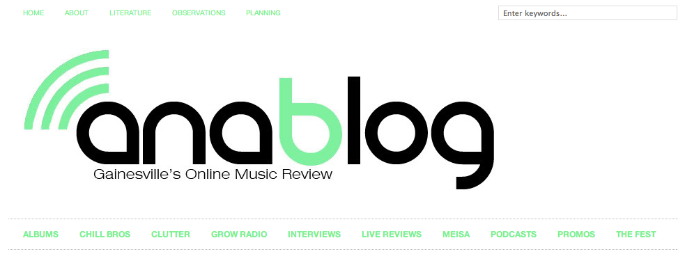
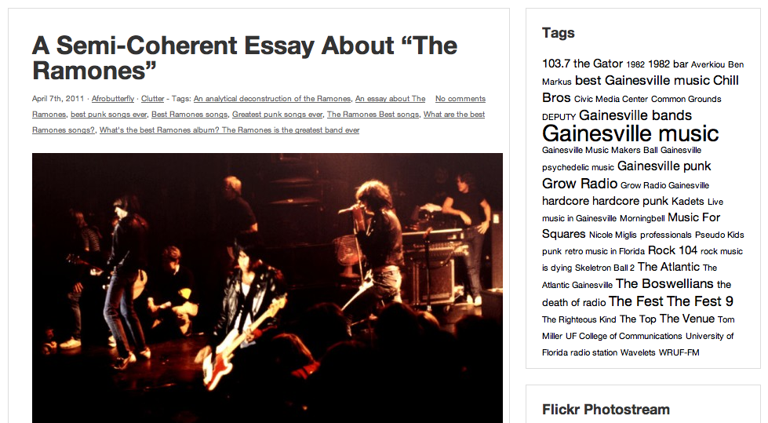
Ana(b)log home page screen capture
My goal for the blog’s design was to create a template that stressed a clean, uncluttered look and easily consumable, multimedia-based information. This was done through the selection of widgets, color and, the design of the banner logo.

Links
The two blogrolls below the “archives” section in the right sidebar designated “Headliners” and “Openers” served a number of purposes. First, they gave readers a sense of similar publications, thereby creating a perception that Ana(b)log was similar to such publications as Chromewaves.net and Brooklynvegan.net. In addition to enhancing identity, the blogrolls also attempted to draw the attention of the linked websites, which have the ability to track referring sites. For example, if a user clicked to Chromewaves.net from Anablogmusic.com, Anablogmusic.com showed up as a referrer in Chromewaves.net’s statistical report. Linking was effective in bringing viewers to the blog as Thezebraowl.wordpress.com, Kylerancourt.com, Gameovermedia.com and No-grain-no-pain.com all added Ana(b)log to their respective blogrolls. In some cases (Gainesville365.wordpress.com, Thegainesvillemusicarchive.tumblr.com, Commongroundslive.com), I added local sites as a show of community solidarity in hopes of tapping into an already established network.
Multimedia
The content of Ana(b)log was built by adding photography, writing, video and audio using cloud applications and social networks such as YouTube, Vimeo, SoundCloud and MP3 downloads via Wordpress.
On Sept. 12, 2010, I established an Ana(b)log YouTube Channel to aggregate all previously uploaded videos into one branded directory. By providing blog information and an Ana(b)log link with each video, I was able to direct 56 users to the blog according to WordPress Stats (though only 14 unique users according to StatCounter Stats) and expose the Ana(b)log name to the approximately 29,000 non-unique viewers who watched my YouTube videos as of March 6, 2011. The Ana(b)log YouTube Channel gained 10 subscribers – including music booking and promotions company Honeycomb Promotions – and 15 friends over the life of this project.
Ana(b)log YouTube Channel stats as of March 6, 2011
I posted my first Vimeo video on Friday, Oct. 29, 2010, and immediately found it an attractive option for formatting video interviews. Over the span of the project, I compiled interviews of Andrew Santorelli, the President of the UF Music and Entertainment Industry Student Association, DJ Robzilla of the hip-hop band O.N.E., Robbie Freeman of local punk band Kadets, Amy Lobasso and Ryan Backman of the Boswellians (via YouTube due to file size restrictions on Vimeo), and Miami recording artist Teepee. The last of these was produced with slides, graphics, transition effects and spliced MP3 clips using Apple’s iMovie program. Teepee subsequently posted the final product to his personal MySpace page with a link back to Ana(b)log.
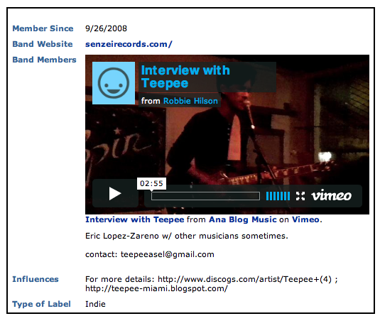
Vimeo video embedded at Myspace.com/teepeeasel
As of March 15, 2011, I had used the SoundCloud media application twice, and, much like YouTube, its social functionality allowed a single sound file to spread the Ana(b)log name exponentially. Because my first two radio episodes at Grow Radio could not be converted to downloadable MP3s (all subsequent episodes would be recorded, converted to MP3s and made available as podcasts both through Growradio.org and Anablogmusic.com), I created my own podcast using a combination of the Audacity Free Audio Editor and Recorder, SoundCloud and personal podcasting equipment. I used a Blue SnowBall podcasting microphone to record the voice parts of the podcast, recording them directly into Audacity. With the permission of Grow Radio, I then interspersed MP3 music files amongst the voice sections, editing the final product down into a 51-minute long file, which I then converted to MP3 format and uploaded in SoundCloud. This process took approximately seven hours.
I then embedded the SoundCloud file in “Music For Squares: Podcast No. 1”, a post reposted on Facebook ten times – one of which by Adam Hallock, a local musician whose song I had included in the podcast. As SoundCloud worked similarly to YouTube in terms of sustaining its own community of users, the SoundCloud file garnered 31 listens at SoundCloud.com as of March 16, 2011. Most of these came within the first week of posting. Like with my YouTube clips, I provided links and additional contact information directing SoundCloud.com listeners back to the blog (though, according to StatCounter, Google Analytics and WordPress Stats, SoundCloud did not make any referrals).
For the second SoundCloud podcast, an interview with the Reitz Union Board’s Jenna Mescon, I recorded a 20-minute conversation using a Kodak PlaySport Camcorder. I then uploaded the video file to YouTube, extracted the sound using the MP3 converter at Listentoyoutube.com, and pared down the interview to nine minutes in Audacity. To level sound levels, I used the Conversations Networks’s Levelator application, a free program that automatically adjusted audio levels. Part of completing this post was a requirement for a graduate course, MMC6936 Multimedia Blogging, with Dr. Judy Robinson. This entire process took approximately six hours, and not including the 90 minutes it took to post the completed interview to Ana(b)log with introductory copy and a photo modified with Photobucket.com, a popular image hosting website.

Observations
The power of social networks was not lost on me. I was, after all, a blogger. And if anybody spends too much time overthinking the perfectly-executed, 140-character blast of Tweeted wit, this person was me. I went into this project aware of the depth and breadth of digitally-faciliated, social connectivity made possible via Facebook and Twitter. So that the speed and synergy by which readers dispersed Ana(b)log content took even this grizzled laptop junkie off guard should give one a sense of the Internet’s truly awe-inspiring power.
It was becoming an increasingly difficult task in this plugged-in global society to find someone who was not connected. And just as Gainesville’s surprisingly versatile music scene circa 2010 ran the gamut from 18-year-old scenesters to self-described “geezer” rockers, so too did the proverbial social network seemingly encapsulate a wide-ranging spectrum of humanity.
This will be made clear in the following anecdote.

Moms and Metal Heads: Ana(b)log In Infancy
The pilot post for Ana(b)log was actually published on my other website Sportscasualties.com. The intentions of this tactic were two-fold. First, as of early September, I had not yet fully developed Ana(b)log’s infrastructure. I was still tinkering with logo design and layout and, rather than publish material on an embryonic template, decided to instead tap into Sports Casualties’ large, Gainesville-based readership as a promotional strategy to drive traffic to the new blog.
The vigor with which metal fans reposted coverage of their favorite thrash-guitar purveyors to Facebook in fact set a benchmark for the content to follow. On Sunday, Sept. 12, 2010, I posted a live review of a joint Azmyth-Whiplash show at The Backstage Lounge. By Monday, the write-up in question had been reposted by 46 unique Facebook accounts and “liked” at multiples beyond that. Though Facebook “likes” were not fully quantifiable given the privacy settings of non-”friends”, one may presume that “likes” outpaced reposts given that 10 people “liked” Azymth’s repost alone.
Evidence of viral promotion to follow:
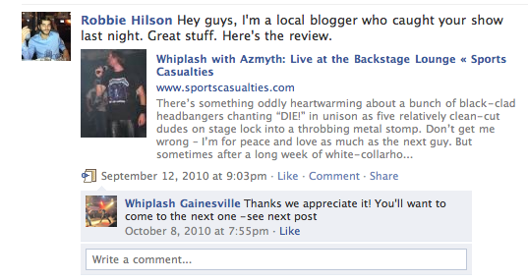

Posted to the Whiplash fan page
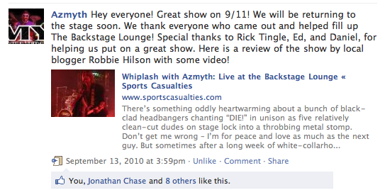

Posted by Azmyth to the Azmyth fan page

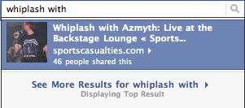
46 Facebook reposts of “Whiplash With Azmyth: Live at the Backstage Lounge
Perhaps unsurprisingly, proud mothers shared content promoting their sons just as diligently as music fans did with their favorite bands. Ana(b)log’s second relatively large burst of exposure, then, came as a direct result of a mother, Renee Puzo, finding a write-up of her son via a Google search. The subsequent chain reaction spawned a swift proliferation of Facebook notifications.
On Thursday, Sept. 30, I talked to the Atlantic’s DJ NickFresh about doing a potential promo. On Saturday I posted “A Word About DJ NickFresh,” and by later that afternoon, Nick’s mother had tipped her son off about the post. Word spread, among other avenues, through Nick’s Twitter account (via retweet), his Facebook page, his Facebook fan page, the Atlantic’s page, and Doowutchyalike Gainesville’s fan page. All told, the post garnered over 150 unique visits within its first week, but the real exciting part was to witness the digitally facilitated magic of this social network tandem unfold in real time.
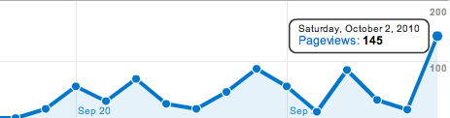

Page Views for Oct. 2, 2010 according to WordPress Stats
(Note: Spikes on Sept. 26 and Sept. 29 equaled 92 and 91 hits, respectively)
Through tagging and reposting on Facebook and retweets on Twitter, this one post reached a large number of Nick’s friends and family within a three-hour period.

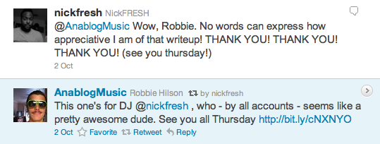

NickFresh retweet of Anablogmusic and subsequent tweet
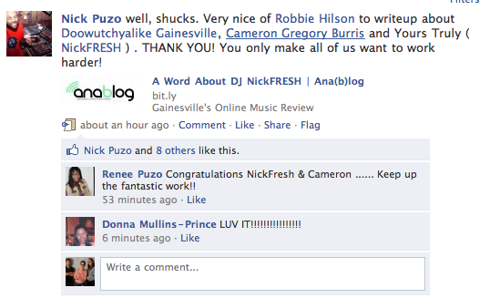Tagged Nick Puzo post on Facebook

28 Facebook reposts
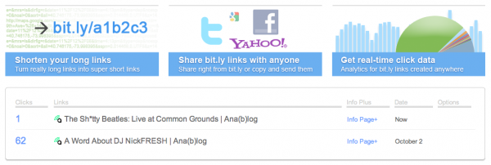

Link shared 62 times according to bit.ly
Activist Hardcore Punk Rockers Love Twitter, Obviously: Ana(b)log A Month In
The site’s biggest traffic day also resulted from a collaborative Twitter/Facebook/YouTube effort, though this time backed by the fan power of a popular East Coast punk band. The setup went as follows: Each year in late October, downtown Gainesville turned into one of the biggest punk music pilgrimages in the country, if not the world. Philadelphia hardcore band “Paint It Black” headlined The Fest 9′s Saturday night show at The Venue and I braved the mass of moshing bodies to shoot photos and record video.
After posting a live review days later on Nov. 1, I contacted the band via Twitter with a snipped bit.ly URL linking to Ana(b)log’s show coverage. Paint It Black proceeded to share the link with their 2,500-strong Twitter following via retweet, and ultimately posted the article to their Facebook page with an additional comment promoting both the review and Ana(b)log. Given the size of the band’s Facebook following – more than 5,000 – it’s quite possible the live review attracted even more impressions when combined with the Twitter exposure and the tagged YouTube videos directing fans to seek out additional material on my blog. Needless to say, Ana(b)log’s traffic spiked in early November, accumulating 322 page views on the first day of the month according to Google Analytics. In addition, as of February 23, 2011, the YouTube video for Paint It Black’s “Past Tense, Future Perfect” – the subject of one of the band’s retweets – had garnered 1,132 views. This subsequent traffic increase stemming from the band’s social media communications suggested a link between artist-fan interaction that extended into the blogosphere. In other words, fans may have been driven by a need to interact with their favorite artists using blogs as mediums. This interaction, in turn, perhaps promoted user attendance.
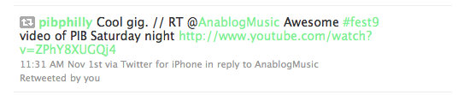

Paint It Black's retweet of Ana(b)log YouTube video
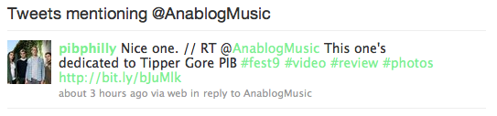

Paint It Black retweet of Ana(b)log live review

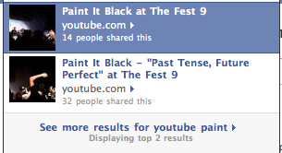

Ana(b)log YouTube videos shared on Facebook
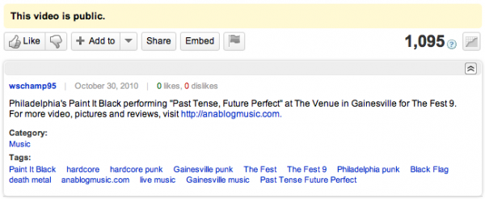

Data for Ana(b)log YouTube video of Paint It Black

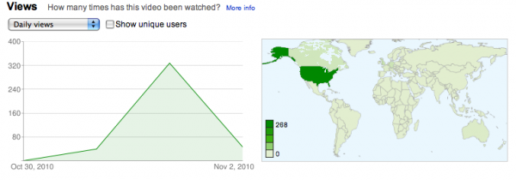

Page views for Nov. 1, 2010 according to Google Analytics
It’s worth noting at this point that in all the previous examples, social media showed groups traditionally associated with active grassroots networks (heavy metal fans, activist punk kids, proud mothers) to behave in very much the way they might have in a pre-Internet age. In 2010, fanzines, obscure record compilations and – in the case of the latter group – clippings reserved proudly for the refrigerator door had been supplemented or all-out replaced by instantaneously dispersible digital information. Though Ana(b)log existed as one case study, evidence showed that communities established through the sharing of “old” media (press clippings, fanzines and record albums, for instances) largely emerged in the digital sphere as similarly intertwined entities. In other words, the concept of niche translated to online social networks, but as an amplified, more easily accessible construct.

Ana(b)log “Grows” Up
Ana(b)log’s Fest coverage made enough of an impact in Gainesville’s independent music community to land the blog a steady stream of modest traffic (approximately 290 hits per week in October and November of 2010 according to WordPress Stats), but more importantly, led to a number of unexpected opportunities that subsequently transformed the Ana(b)log name into a multi-platform endeavor.
At this juncture, it is necessary to quickly touch on the rationale behind using three different statistical tracking programs. Though WordPress Stats recorded page views, and was thus convenient for quickly measuring traffic, it was unable to distinguish between “unique visitors” and return visitors – those who visited the blog more than once. StatCounter came in handy here, as it was capable of these measures and was also able to track where site visitors came from.
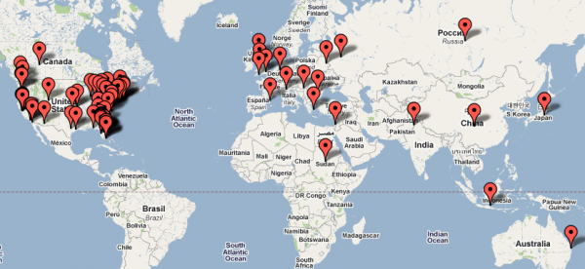StatCounter "Recent Visitor Map" for March 8, 2011
StatCounter also kept track of entry and exit pages, download activity and “search engine wars” – an analytic tool showing from which search engine visitors came (on the downside, StatCounter’s data log tops out at 500 entries without a premium pay-per upgrade). I employed Google Analytics because it detailed similar metrics, and because it acted as a backup should the embedded StatCounter code have encountered an unexpected complication. This coding snag in fact affected Google Analytics when I updated Ana(b)log’s content management system to WordPress version 3.1.1. I subsequently lost all archived data prior to February 15 and relied primarily on old screen captures to relate the provided Google Analytics statistics. Together, the three analytics programs acted as checks on one another and, given their varying statistical calculations, provided a range of figures by which to estimate Ana(b)log’s true traffic totals.
Site usage data for Feb. 14 through March 7 according to Google Analtyics
After jumping from 838 page views in October to 1,788 page views in November according to WordPress Stats (StatCounter shows 1,059 and 2,084 views, respectively), Ana(b)log’s visits declined to 710 in December due presumably to the University of Florida’s winter break, and the author’s corresponding break, as well as the natural decline one would expect in the wake of the successful Fest 9 coverage. Page views steadily rose in the new year, however, as the site fetched 1,087 views in January and then climbed to 1,380 in February on an average of two to three posts per week.
The reasons for this growth largely dealt with the sites transformation into a multimedia outlet for all things Gainesville music. In a roughly three-month span from the end of September to the beginning of January in which I posted between two and three times per week, Ana(b)log evolved from an outlet based solely on reporting-focused journalism into a community partner for local Internet radio and a hub for podcasting. The interim, however, should not be glossed over, as its events fostered a slow, but consistent growth in influence and exposure aligning with a gradual climb up the search engine rankings. Moreover, in keeping with journalist Chris Baltimore’s findings that blogs generate word-of-mouth publicity better than traditional media, Ana(b)log evolved into a taste-making publication with content employed by local artists to create “buzz”. In this regard, the blog became a destination for music fans, industry professionals, and the artists themselves.
It was during this period, for instance, that my “tell all” interview with an ex-Rock 104 DJ sparked a conversation among local radio professionals at Radio-Info.com. The interview tallied more than 120 unique visits according to Google Analytics, landed a referral that marginally enhanced Ana(b)log’s influence, and more importantly, shed light on a sticky situation that had otherwise been sparsely reported on.
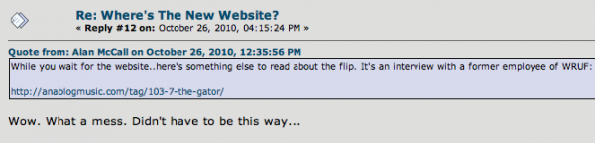
Oct. 26 message board posting at Radio-Info.com
The interview also caught the attention of a fellow Gator alumnus who, for her part, just happened to front a locally-popular indie rock band in Tallahassee. Her band wanted to plug a gig at Gainesville’s Backstage Lounge in October. She contacted me, writing the following:
Greetings!
I came across your anablog (very cool, btw) and thought I’d drop you a line.
We’re a band called Fantome from Tallahassee, and we’re getting ready to make our first visit to Gainesville. We will be playing @ the Backstage Lounge this Friday night, Oct. 1st. People describe us as post punk and shoegaze.
I’m a UF journalism grad, but I haven’t lived in G-ville for a while. Most of my UF friends have moved away. I’m just trying to reach out to some cool folks who might be interested in our show.
We just released our 2nd album, Bare Mythology, which you can download for FREE at:
http://fantomeband.bandcamp.com
If there is any way you could help us spread the word about our show, we’d really appreciate it. Perhaps we could return the favor with a t-shirt or some beer
Thanks for your time, and we hope to see you at the show!

Tracy http://www.myspace.com/fantomeband
Occurrences as these suggested that Ana(b)log had filled a need in the local music community previously met only by stop-gap publications (http://hearingainesville.wordpress.com/, for example) unable to sustain a long-term flow of content. Though several credible, Florida-based music blogs had bubbled up circa 2010, few if any had focused their attention squarely on Gainesville, and the ones that did did so only in spurts.
After tweaking its WordPress tagline to “Covering Gainesville Indie Music Bands” to include more pertinent Google AdWords, a Google search for “Gainesville indie music” returned Anablogmusic.com as the third overall result as of March 17, 2011, and this behind community stalwarts Common Grounds Live (the city’s premier rock venue) and The Gainesville Music Archive (Gainesvillemusicarchive.tumblr.com). It was evident, then, that bands – especially regional acts and touring outfits unfamiliar with the Gainesville scene – benefited from the creation of an exclusively hyper-local music publication with the flexibility to produce quickly distributable promotional material. The rate at which the Fantome promo was shared certainly speaks to this point.
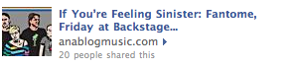

Fantome Promo Facebook reposts
Subsequent contacts – namely, by Mobile, AL, space-rockers The Sunshine Factory, St. Paul, MN, folk singer We Are The Willows, and local music vet Bob McPeek, bandleader of garage-revivalists The Erasables – certainly attested to the appeal of Ana(b)log’s promotional capabilities as well.
Ana(b)log finally came into its own via an unexpected, though certainly not unwelcome, offer from Grow Radio‘s Bill Bryson. Much like Ana(b)log’s correspondence with Fantome’s Tracy Horenbein, the Grow Radio connection emanated mainly by chance and through a third-party contact. In November, I covered Gainesville rock band Driver at Common Grounds. Driver’s Naheed Mojadidi, host of Grow’s “Erosion“, enjoyed the subsequent review enough to ask me to write a piece for her fanzine (also called “Erosion”). Of greater significance Naheed passed my name along to Bryson, Grow’s founder and station programmer.
By early January, after a couple meetings to discuss potential show formats and the actual logistics of working a soundboard, I was creating and hosting the all-local “Music For Squares” – a weekly, hour-long program dedicated specifically to Gainesville music and the touring artists passing through.
“Music For Squares” – so named for Gainesville’s rectangular configuration – quickly developed into Ana(b)log’s podcasting arm, a collaborative coup d’ etat allowing me to A) utilize the station’s technological capabilities to create downloadable podcasts and B) play both the music available at the station and my own material without having to acquire permissions from each individual band (though it was my overwhelming experience that local bands, most of whom freely distributed their material anyway, wanted the exposure without the hassles of granting any potential copyright permission).
This perhaps goes without saying, but the Grow connection both bumped the blog’s popularity and allowed me to make further inroads in the local music community. What unfolded, then, proved an exercise in synergy: “Music For Squares” increased Ana(b)log’s exposure and credibility; Ana(b)log touted Grow and all things local internet radio.

As each of the previous anecdotes illustrated, the story of this blog was one of spontaneous connections and optimization of social networks. Comments to Facebook and to the blog substantiated this claim, as approximately 27 different readers commented directly on the blog alone. In addition, several artists sent emails both complimenting Ana(b)log and soliciting coverage. In the span of five months, I was contacted by, among others:
- Dante Lima of the Gainesville Sun, a reporter and music critic who asked me to review an album for his band Pseudo Kids 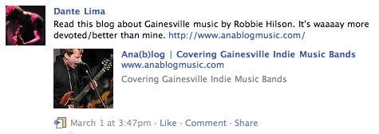
Facebook posting by Gainesville Sun music critic Dante Lima
- Rock 104’s Glenn Rickard, a Gainesville DJ who asked for help in compiling music for a local music show
- DJ NickFresh, who contacted me a second time to promote his Thursday night Doowhatchyalike Gainesville dance parties at The Atlantic Nightspot
- Bob McPeek, founder of Hyde & Zeke Records, Mirror Image Studios, and the principal songwriter in The Erasables
- Vice Magazine, a prominent national publication that asked me to cover an event it sponsored at The Atlantic Nightspot
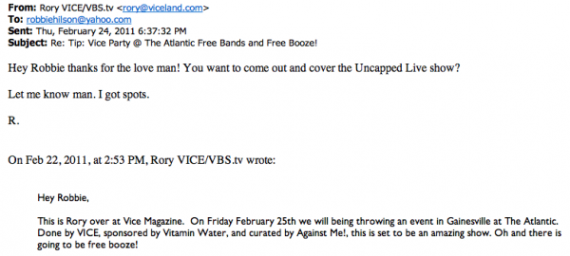
Correspondence with Rory Ahearn of Vice Magazine
- Deputy, a project of Morningbell drummer Chris Hillman
- The Boswellians and Kadets, two local acts
- Ancient River, a popular local band who transcribed a clip of an Ana(b)log live review and an entire album review under the “Press” section of its website
- The manager of Alabama band The Sunshine Factory, to cover a tour stop in Gainesville
- Minnesota folk artist We Are The Willows, also to cover a local tour stop
- The UF Music and Entertainment Industry Student Association
- Charles Martin, both a physics professor at UF and the songwriter for local psychedelic band The Righteous Kind
- Bill Bryson of Grow Radio, who, as previously detailed, asked me to host a weekly local show

Discussion
Building Rapport
In keeping with a 2005 study by Trammel and Keshelashvili that found a strong correlation between blog popularity and a blogger’s willingness to disclose personal information, Ana(b)log strove to develop a strong, first-person voice to establish a casual, comfortable rapport with both readers and the subjects of the blog themselves. Ana(b)log’s largely positive, but objective reviews of artists helped in this respect – the blog’s analytical, though often complimentary analysis freed artists to solicit reviews and grant interviews without the fear of negative publicity. Established blogs and print publications in 2010 did not typically take such a one-sided, predominantly positive approach to criticism. This proved a central difference between Ana(b)log and an outlet like the Gainesville Sun. However, when one started from scratch without previous credentials, it was imperative not to burn bridges or potential relationships with unfavorable press, especially when running a one-person operation in such a small, close-knit community.
While some bloggers, including Martyn Chamberlin of Two Hour Blogger, argued that personal style was irrelevant to driving traffic and establishing a readership, for Ana(b)log, it was the primary feature that distinguished blogs with similar informational content. Chamberlin wrote in a February 2011 post for Problogger.net (http://www.problogger.net/archives/2011/02/20/teach-or-your-blog-will-die/) that a blog must teach, or it will die. This was wise advice to a degree in that the ability to inform audiences contributed to a blog’s success. By providing interviews, photos, video of live performances and reviews, Ana(b)log informed its audience about Gainesville’s indie music scene. However, the ability to entertain was very vital, especially for a music publication existing in a digital environment in which audiences could simply visit YouTube to hear new music.
Online music criticism had an especially rich tradition of personality-heavy first-person voice. Seminal Web critics like Mark Prindle of Markprindle.com and Scott Floman of Sfloman.com built large audiences and equally impressive influence (Prindle went on to write for Crawdaddy Magazine in 2010 and occasionally appeared on Fox News’ “Red Eye” program) with an irreverent blend of personal anecdote, humor, first-person narrative and a total dismissal of AP style. These characteristics, of course, did not stand on their own. Thus Ana(b)log emphasized quality of information over all else – an attribute that imbued it with an air of professionalism conducive to positive reader-blogger and artist-blogger interactions.

Knowing One’s Audience
The prior discussion of building blogger-audience rapport spawned a related question: how did a blogger get to know the audience? To establish Ana(b)log’s readership, I took a proactive approach not just with social media, but also as a participant in the Gainesville music community. As Ana(b)log was a reporting-based publication, I went to my sources, establishing a face-to-face relationship with multiple artists as any good reporter would. Over the course of six months, I regularly attended bi-weekly meetings of the University of Florida’s Music and Entertainment Industry Student Association, went on average to one show per week at a cost of $6-8 each, attended most of the major music events (like the Gainesville Music Maker’s Ball and The Fest), and, in all cases, talked to the performers involved. I knew my audience because I was part of my audience. I put myself in readers’ shoes and would advise all bloggers looking to grow an online presence to do the same, asking, “If I came across this post, would it both hold my attention for its duration and leave me hungry for more?” Along those same lines, the most successful bloggers have been ones that exploited a niche by providing original content. Consequently, bloggers must survey their environment, researching competitors and potential partner publications to carve out an area of specialty. For Ana(b)log, this entailed focusing heavily on live, local music reviews and multimedia-based reporting of lesser known bands, neither of which had been previously concentrated on.

Growing a Community: Advice for Future Bloggers
Scanning one’s environment and analyzing the audience were first steps to growing a readership. With social media providing multiple outlets for reader discussion, one must also attempt to harness audience feedback – both with the blogger and other readers – by either confining it to a single location or creating synergies between social media applications. With Ana(b)log, readers submitted comments through YouTube, Facebook, Twitter and email, and made it difficult to focus conversation while simultaneously spreading thin the time and attention of the blogger. The goal, then, was to efficiently collate reader interactions without limiting potential feedback avenues. The social media application WordBooker helped in this regard, as it transcribed Facebook comments directly to the blog post. Providing an RSS feed of Ana(b)log’s Twitter correspondence in the sidebar of Anablogmusic.com also helped to aggregate dialogue in one place. Ideally, a blogger should strive to collect comments in one easily accessible location to generate further conversation.
Bloggers should also tap into preexisting communities if at all possible. This, again, requires an awareness of one’s place in the blogosphere and a willingness to advertise oneself. Over the course of this project, Ana(b)log was able to develop a synergistic relationship with Grow Radio in which use of the station’s facilities and access to its on-air personalities was reciprocated with Ana(b)log coverage. The relationship between the two shed light on how the Internet worked in general: similar communities connected with one another through social media and then utilized each other’s existing resources. Such an interaction occurred every time an artist promoted an Ana(b)log post via retweet or Facebook repost: the band benefited from the spread of positive press while Ana(b)log benefitted from the increased exposure and bump in traffic.
Furthermore, bloggers should emphasize consistency of posting. Posting two to three times per week at two to three-day intervals proved a relatively successful strategy for building Ana(b)log’s community, as dedicated readers would typically check in on off days to make sure they hadn’t missed anything. This strategy kept traffic relatively constant throughout the week. Providing quality content that combines features of search engine optimization (SEO) with well-written prose and engaging multimedia helps as well. While SEO should not have been employed at the expense of content, its reputation as an “attempt to game the system” was not entirely fair. The use of both well-constructed permalinks (those that included popular keywords) and efficient tagging was helpful in driving traffic, as it helped potential audiences find content more easily. To this implementation of SEO, bloggers should additionally concentrate on posting on a regular basis, a strategy that in time attracted both an audience and search engine crawlers. It was beneficial to Google searchers, for instance, to include popular keywords in the title of a post, but such a strategy should be employed with creativity and readability in mind. In general, the more posts a blog had, the better it performed in Google searches because the larger body of work provided more indexed words as a database for searched words.
Hyperlocal blogs, particularly ones that fulfill an original niche, should also focus on link coverage and making contacts through social media, as these proved effective strategies for building an audience in a short amount of time. Kylerancourt.com and Radio-info.com, both sites that linked to Anablogmusic.com, were two of my blog’s top referrers. This spoke to the value of linking. Tapping potential local audiences through Facebook, Twitter, SoundCloud and YouTube was also advantageous in quickly establishing a readership.

Bloggers should never pass up a moment of inspiration. The best posts were often the most effortless. Similarly, the pursuit of perfection should not stifle content production. The beauty of blogging was in its informality, transience and ease of publishing. If today’s post didn’t turn out exactly how the blogger envisioned, there was always tomorrow.

References
Alder, P., & Kwon, S. W. (2002). Social capital: Prospects for a new concept. The Academy of Management Review, 27(1), 17-40.

Baltimore, C. (2009, March 9). Bloggers: Music industry tastemakers? Message posted to http://blogs.reuters.com
Blumler, J. G., & McQuail, D. (1969). Television in politics: Its uses and influence. Chicago: University of Chicago Press.
Bonds-Raacke, J., & Raacke, J. (2010). MySpace and Facebook: Identifying dimensions of uses and gratifications for friend networking sites. Individual Differences Research, 8(1), 27-33. Retrieved from the Academic Search Premier database.

Caramanica, J. (2010, July 14). Upstart music site becomes establishment. The New York Times. Retrieved from http://www.nytimes.com/2010/07/15/arts/music/15pitchfork.html
Chen, Y. H., & Corkindale, D. (2008). Towards an understanding of the behavioral intention to use online news services. Internet Research, 18(3), 286-312. doi: 10.1108/10662240810883326

Chyi, H., & Mengchieh Jacie, Y. (2009). Is online news an inferior good? Examining the economic nature of online news/ among users. Journalism & Mass Communication Quarterly, 86(3), 594-612. Retrieved from Communication & Mass Media Complete database.

D’Arcangelo, G. (2005). The new cosmopolites: Activating the role of mobile music listeners. Paper presented at the 2nd International Workshop on Mobile Music Technology for NIME ’05, Vancouver, Canada.

Diddi, A., & Larose, R. (2006). Getting hooked on news: Uses and gratification and the formation of news habits among college students in an internet environment. Journal of Broadcasting and Electronic Media, 50(2), 193-210.

Eastin, M., & LaRose, R. (2003). A social cognitive explanation of internet uses and gratifications: Toward a new theory of media attendance. Conference Papers -- International Communication Association, 1-36. doi:ica_proceeding_11705.PDF.

Herzog, H. (1954). Motivations and gratifications of daily serial listeners. In W. Schramm (Ed.), The processes and effects of mass communication (pp. 50-55). Urbana, IL: University of Illinois Press.
Johnson, T., & Kaye, B. (2004). Wag the blog: How reliance on traditional media and the internet influence credibility perceptions of weblogs among blog users. Journalism & Mass Communication Quarterly, 81(3), 622-642.

Johnson, T., & Kaye, B. (2008). In blog we trust? Deciphering credibility of components of the internet among politically interested internet users. Computers In Human Behavior. doi:10.1016/j.chb.2008.08.004

Katz, E. (1959). Mass communication research and the study of popular culture: An editorial note on a possible future for this journal. Studies in Public Communication, 2, 1-6. Retrieved from http://repository.upenn.edu.
Katz, E., Blumler, J. G., & Gurevitch, M. (1974). Utilization of mass communication by the individual. In O. Boyd-Barrett & C. Newbold (Eds.), Approaches to media: A reader (pp. 164-173). London: Arnold.

Katz, E., Gurevitch, M., & Haas, H (1973). On the use of the mass media for important things. American Sociological Review 38(2), 164-181. Retrieved from http://www.jstor.org/pss/2094393
King, A. (2001). Affective dimensions of internet culture. Social Science Computer Review, 19(4), 414-430. doi: 10.1177/089443930101900402
Lee, D., Im, S., & Taylor, C. (2008). Voluntary self-disclosure of information on the internet: A multimethod study of the motivations and consequences of disclosing information on blogs. Psychology and Marketing, 25(7), 692-710. DOI: 10.1002/mar.20232

Levy, M. R. (1978). The audience experience with television news. Lexington, KY: Association for Education in Journalism.
Li, D. (2005). Why do you blog: A uses-and-gratifications inquiry into bloggers’ motivations (Master’s thesis).

Liu, I., Cheung, C., & Lee, M. (2010). Understanding Twitter usage: What drive people continue to Tweet. Pacific Asia Conference on Information Systems: Proceedings of the 2010 PACIS Conference, Taipei, Taiwan (paper 92).

McQuail, D., J.G. Blumler, & Brown, J. R. (1972). The television audience: A revised perspective. In P. Marris & S. Thornham (Eds.), Media Studies: A reader (pp. 438- 454). New York: New York University Press.

Milani, L., Osualdella, D., & Di Blasio, P. (2009). Quality of interpersonal relationships and problematic internet use in adolescence. CyberPsychology & Behavior, 12(6), 681- 684.

O'Donnell, P., & McClung, S. (2008). MP3 music blogs: Their efficacy in selling music and marketing bands. Atlantic Journal of Communication, 16(2), 71-87. doi:10.1080/15456870701840004.

Palmgreen, P., Wenner, L. A., & Rayburn II, J. D. (1981). Gratification discrepancies and news program choice. Communication Research, 8(4), 451-478.
Perse, E. (1990). Media involvement and local news effects. Journal of Broadcasting & Electronic Media, 34(1), 17-36.

Ruggiero, T. (2000). Uses and Gratifications Theory in the 21st Century. Mass Communication & Society, 3(1), 3-37.

Shao, G. (2009). Understanding the appeal of user-generated media: A uses and gratification perspective. Internet Research, 19(1), 7-25.

Shen, C. C., & Chiou, J. S. (2009). The effect of community identification on attitude and intention toward a blogging community. Internet Research, 19(4), 393-407.

Schmidt, J. (2007). Blogging practices: An analytical framework. Journal of Computer- Mediated Communication, 12(4), 1409-1427.

Schwartz, D. (2009). Knowing who you are and trusting who you know. Internet Research, 19(5). Introductory essay retrieved from http://www.emeraldinsight.com/

Shirky, C. (2008). Here comes everybody: The power of organizing without organizations. New York: Penguin Books.
Song, I., Larose, R., Eastin, M. S., & Lin, C. A. (2004). Internet gratifications and internet addiction: On the uses and abuses of new media. CyberPsychology & Behavior, 7(4), 384-394.

Stafford, L., Kline, S., & Dimmick, J. (1999). Home e-mail: Relational maintenance and gratification opportunities. Journal of Broadcasting & Electronic Media, 43(4), 659- 669. Retrieved from Academic Search Premier database.

Stafford, T., Stafford, M., & Schkade, L. (2004). Determining uses and gratifications for the internet. Decision Sciences, 35(2), 259-288. Retrieved from Google Scholar.

Trammell, K., & Keshelashvili, A. (2005). Examining the new influencers: A self- presentation study of A-list blogs. Journalism & Mass Communication Quarterly, 82(4), 968-982. Retrieved from Communication & Mass Media Complete database.

Verplanken, B. (2006). Beyond frequency: Habit as mental construct. British Journal of Social Psychology, 45(3), 639-656. DOI: 10.1348/014466605X49122

Zerba, A. (2003). Perceived motives for clicking on multimedia features on news web sites: An exploratory study (Master’s thesis). Available from the University of Florida Online Dissertations database.

Appendix

Example Post (Text transcribed below)

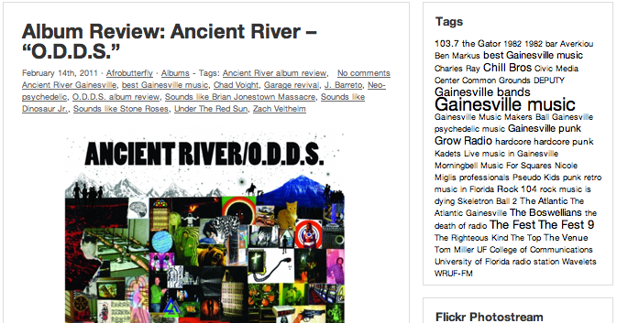
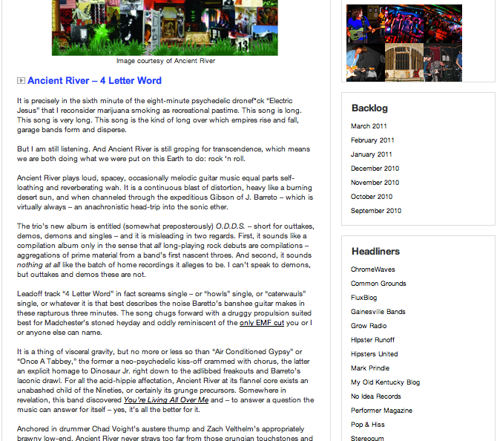
Full text:
It is precisely in the sixth minute of the eight-minute psychedelic drone**** “Electric Jesus” that I reconsider marijuana smoking as recreational pastime. This song is long. This song is very long. This song is the kind of long over which empires rise and fall, garage bands form and disperse.
But I am still listening. And Ancient River is still groping for transcendence, which means we are both doing what we were put on this Earth to do: rock ‘n roll.
Ancient River plays loud, spacey, occasionally melodic guitar music equal parts self-loathing and reverberating wah. It is a continuous blast of distortion, heavy like a burning desert sun, and when channeled through the expeditious Gibson of J. Barreto – which is virtually always – an anachronistic head-trip into the sonic ether.
The trio’s new album is entitled (somewhat preposterously) O.D.D.S. – short for outtakes, demos, demons and singles – and it is misleading in two regards. First, it sounds like a compilation album only in the sense that all long-playing rock debuts are compilations – aggregations of prime material from a band’s first nascent throes. And second, it sounds nothing at all like the batch of home recordings it alleges to be. I can’t speak to demons, but outtakes and demos these are not.
Leadoff track “4 Letter Word” in fact screams single – or “howls” single, or “caterwauls” single, or whatever it is that best describes the noise Baretto’s banshee guitar makes in these rapturous three minutes. The song chugs forward with a druggy propulsion suited best for Madchester’s stoned heyday and oddly reminiscent of the only EMF cut you or I or anyone else can name.
It is a thing of visceral gravity, but no more or less so than “Air Conditioned Gypsy” or “Once A Tabbey,” the former a neo-psychedelic kiss-off crammed with chorus, the latter an explicit homage to Dinosaur Jr. right down to the adlibbed freakouts and Barreto’s laconic drawl. For all the acid-hippie affectation, Ancient River at its flannel core exists an unabashed child of the Nineties, or certainly its grunge precursors. Somewhere in revelation, this band discovered You’re Living All Over Me and – to answer a question the music can answer for itself – yes, it’s all the better for it.
Anchored in drummer Chad Voight’s austere thump and Zach Velthelm’s appropriately brawny low-end, Ancient River never strays too far from those grungian touchstones and as a result manage to avoid most of the indulgent trappings of its oft-formless genre. With a few exceptions (“While You Were Gone”, “Changing Skies”), most of these songs are actual songs, employing ambience and wankery primarily as vehicles for catharsis. “No Apology”, for instance, careens into tranquilizing nothingness right up until, invariably, Barreto pulls the ripcord with a shard-laced solo.
So, yes, in moments as these – the blistering final heave of stoner dirge “Places No One Knows,” the sixth minute of “Electric Jesus” – I very much wish I’d said yes in the high school parking lot. I wish I had longer hair. I wish I drove a Plymouth Superbird. I wish I could rock ‘n roll like Ancient River.
To purchase O.D.D.S, visit AncientRiverMusic.com or download the album on iTunes.

Most Visited Post According To WordPress Stats (Text Transcribed Below)
- 181 unique visitors
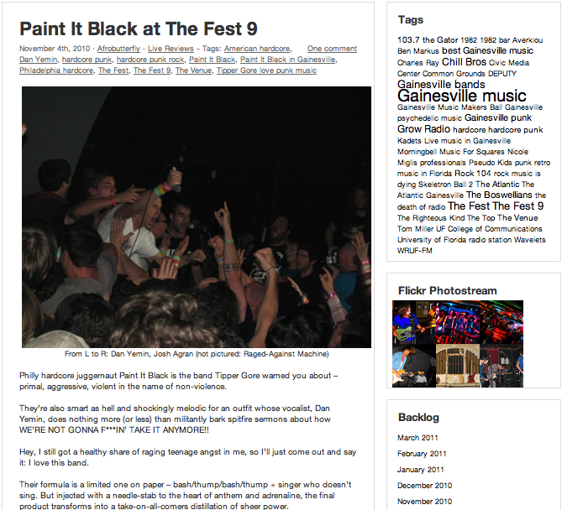
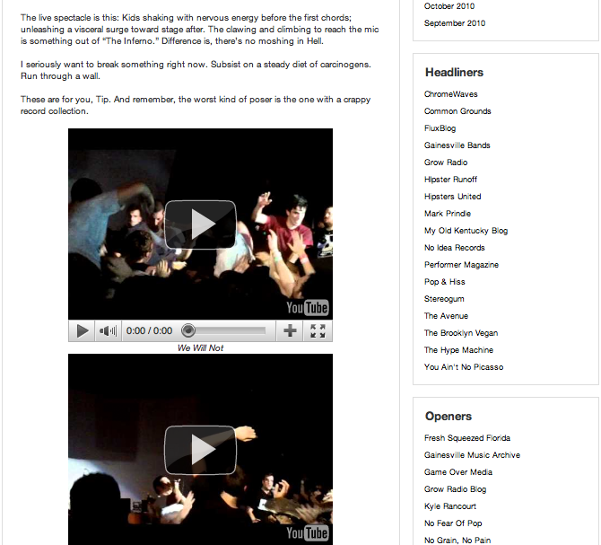
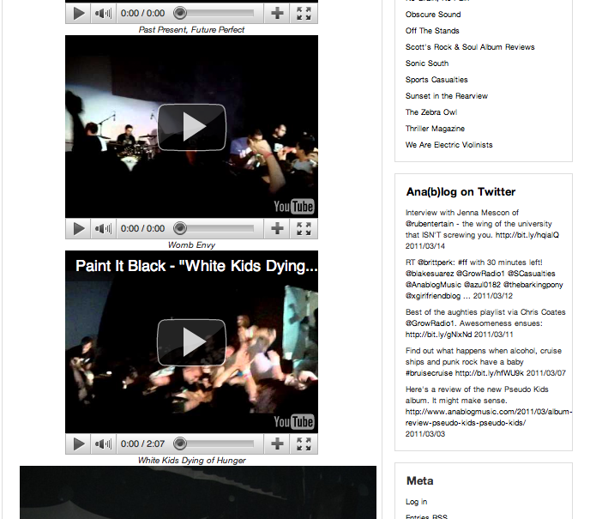
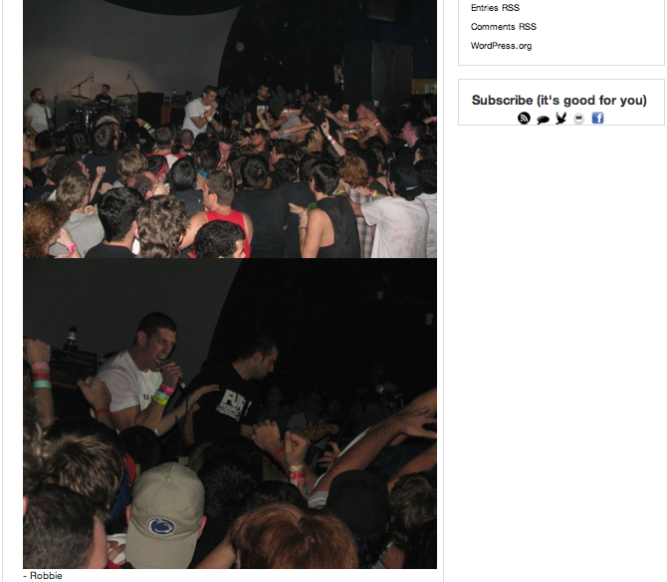
Full text:
Philly hardcore juggernaut Paint It Black is the band Tipper Gore warned you about – primal, aggressive, violent in the name of non-violence.
They’re also smart as hell and shockingly melodic for an outfit whose vocalist, Dan Yemin, does nothing more (or less) than militantly bark spitfire sermons about how WE’RE NOT GONNA FREAKIN’ TAKE IT ANYMORE!!
Hey, I still got a healthy share of raging teenage angst in me, so I’ll just come out and say it: I love this band.
Their formula is a limited one on paper – bash/thump/bash/thump + singer who doesn’t sing. But injected with a needle-stab to the heart of anthem and adrenaline, the final product transforms into a take-on-all-comers distillation of sheer power.
The live spectacle is this: Kids shaking with nervous energy before the first chords; unleashing a visceral surge toward stage after. The clawing and climbing to reach the mic is something out of “The Inferno.” Difference is, there’s no moshing in Hell.
I seriously want to break something right now. Subsist on a steady diet of carcinogens. Run through a wall.
These are for you, Tip. And remember, the worst kind of poser is the one with a crappy record collection.

Top Posts for All Days Ending March 17, 2011 According to WordPress Stats
Home page | 4,033
Gainesville, Thursday Night: A Playlist | 299
Paint It Black at The Fest 9 | 181
Interview with The Boswellians | 103
The Rock 104 Interview with Ben Markus | 94
Local Radio “Grows” Up | 84
The Sh*tty Beatles: Live at Common Grounds | 83
Skeletron Ball 2: Night 1 | 83
About | 71
Michael Parallax at The Atlantic | 68
Vice Magazine throws FREE party at The Atlantic this Friday | 65
Why is the bro from Dead To Me so angry, y’all? | 65
To All My Dear Friends at The Atlantic | 65
Album Review: Deputy – “Filthy Stinkers” (NSFW) | 62
Interview with Teepee | 59
Skeletron Ball 2: Night 2 | 56
Album Review: Pseudo Kids – “Pseudo Kids” | 55
Introducing: Internet Sensation Kyle Rancourt | 55
Interview With Tom Miller of The Righteous Kind: Pt. 1 | 53
Doowutchyalike Gainesville: What You Missed | 50
“Music For Squares”: Podcast No. 1 | 50
Interview with UF MEISA’s Andrew Santorelli | 42
Plastic Plastic at The Atlantic | 41
Dear Mr. Anderson… | 38
A Top 5 for The Top | 38
Metallica plus Stubbies = Alcoholica? | 35
Fest Interview with Robbie Freeman of Kadets | 33
Interview with R.U.B. Entertainment’s Jenna Mescon | 32
Kadets at 1982 | 32
Wavelets at 1982 | 30
Hard Skin at The Venue: The Fest, Day 1 | 29
The Rock 104 Interview: Part 2 | 27
10-4 Eleanor at 1982: The Fest, Day 1 | 26
Sweet Bronco, Driver and Ancient River: Live at Common Grounds | 25
Listening to records with Jonathan Richman | 24
The Rock 104 Interview: Part 3 | 24
Chotto Ghetto: An Intro to the Fest 9 | 21
A Word About DJ NickFRESH | 21
Defiance, Ohio at 8 Seconds: The Fest, Day 2 | 20
Interview with DJ Robzilla of O.N.E. | 20
The Rock 104 Interview: Part 4 | 20
Album Review: Ancient River – “O.D.D.S.” | 20
Grow Radio Sends Off The White Stripes | 19
Grow Radio’s “Music For Squares”: Episode 8 | 19
Ana(b)log Crashes “Left Of The Dial” | 18
Ring In The Belated New Year With “Music For Squares” | 18
A Wilhelm Scream at The Venue: The Fest, Day 1 | 18
Bruise Cruise Recap | 16
Observations | 15
If You’re Feeling Sinister: Fantome, Friday at Backstage Lounge | 14
Ex-Rock 104 DJ Finds Job | 14
Is Radio the best pop song of the Nineties? | 13
The Sound, The Fury, The Faux-Hawk: Thieves and The Stampede at 1982 | 11
The Captives: Live at The Venue | 11
Interview With Tom Miller of The Righteous Kind: Pt. 2 | 11
Waking up to “Sweet Leaf” | 11
Music For Squares, Pt. 1: Averkiou | 10
Grow Radio’s “Music For Squares”: Episode 3 | 10
Thankfully… I’m Still Alive! WOOT WOOT! | 10
Interview with Tom Miller of The Righteous Kind: Pt. 3 | 9
Whiplash with Azmyth: Live at the Backstage Lounge | 9
AM/FM Gainesville Music Showcase x 3 Bands | 8
Interview with Dave Melosh | 8
Planning | 5
Tanks In Series at The Atlantic | 5
Literature | 4
UF MEISA Benefit Show | 4
We Are The Willows: Live at Common Grounds | 3
Grow Radio’s “Music For Squares” – Episode 9 | 1

Weekly Hits According to WordPress Stats
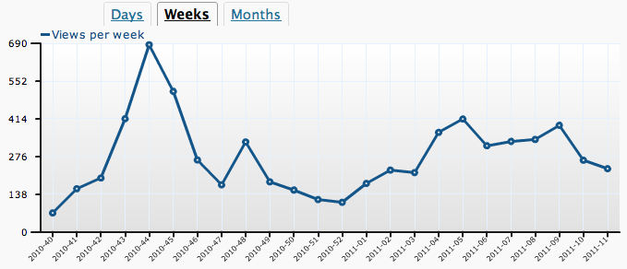
Monthly Hits According to WordPress Stats
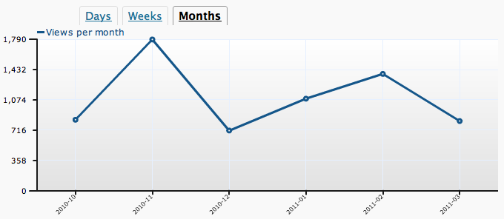

Weekly Hits According to StatCounter
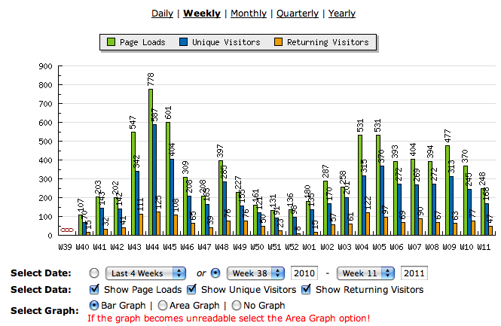

Weekly Hits According to StatCounter (Continued) 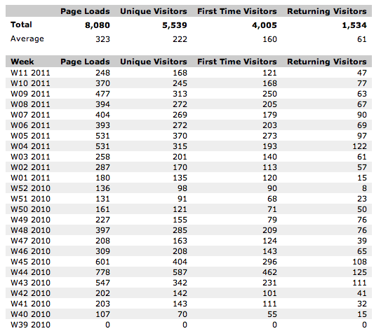

Monthly Hits According To Statcounter
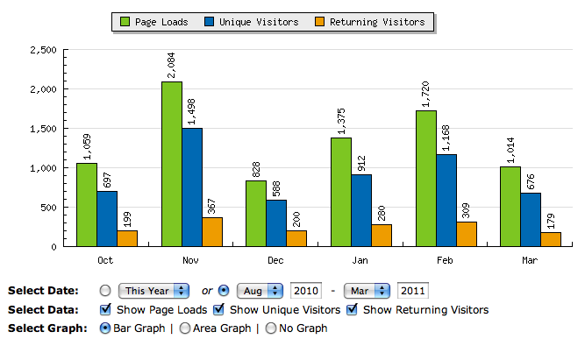
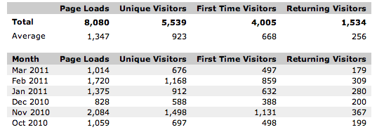

Referrers for All Days Ending March 17, 2011 According to WordPress Stats
Referrer | Views
facebook.com | 517
boards.radio-info.com/smf/index.php?topic=177625.10 | 54
thinkmultimedia.wordpress.com | 50
twitter.com | 44
anablogmusic.com. | 38
youtube.com/user/wschamp95 | 22
kylerancourt.com | 22
toallmydearfriends.com/press.html | 12
gainesvillebands.com/forum/forum_posts.asp?TID=31040&PN=1 | 12
WordPress Dashboard | 10
google.com | 9
sportscasualties.com | 8
youtube.com/watch?v=S7Fc_6Eb7Ss | 8
twitter.com/pibphilly | 7
healthyfoodlazypeople.com | 7
twitter.com/anablogmusic | 7
gainesvillebands.com/forum/forum_posts.asp?TID=31307&TPN=2 | 6
youtube.com/watch?v=VWozvA84oUQ | 5
youtube.com/watch?v=5zXvmBfbBO0 | 5
twitter.com/SCasualties | 5
gainesvillebands.com/forum/forum_posts.asp?TID=31307&PN=1&TPN=2 | 5
sportscasualties.com/2011/02/18/breaking-melo-to-nets-hilson-right-again-i-am-the-effing-man-etc | 4
youtube.com/watch?v=Rjm-pUfMKW4 | 4
touch.facebook.com/l.php?u=http%3A%2F%2Fanablogmusic.com%2F&h=65280 | 4
no-grain-no-pain.com | 4
ancientrivermusic.com/press.html | 4
youtube.com/watch?v=2givNmwGfvU | 4
facebook.com/l.php?u=http://anablogmusic.com/2010/12/metallica-plus-stubbies-alcoholica/&h=98665 | 4
youtube.com/watch?v=vrfxtTJPs0k | 4
facebook.com/l.php?u=http://anablogmusic.com/&h=65280 | 4
youtube.com/watch?v=xdZ2BWbWQfg | 4
gainesvillebands.com/forum/forum_posts.asp?TID=31307&PN=0&TPN=2 | 4
facebook.com/l.php?u=http://anablogmusic.com/&h=045b8 | 3
kickbrightzine.com | 3
facebook.com/l.php?u=http://anablogmusic.com/&h=f49fe | 3
youtube.com/watch?v=qXecNxfO6lw | 3
facebook.com/l.php?u=http://anablogmusic.com/2010/11/skeletron-ball-2-night-1/&h=0493c | 3
facebook.com/l.php?u=http://anablogmusic.com/2010/12/metallica-plus-stubbies-alcoholica/&h=89e60 | 3
facebook.com/l.php?u=http://bit.ly/99tugL&h=6245b | 3
facebook.com/l.php?u=http://bit.ly/99tugL?ref=nf&h=58aee | 3

Sample Screen Captures
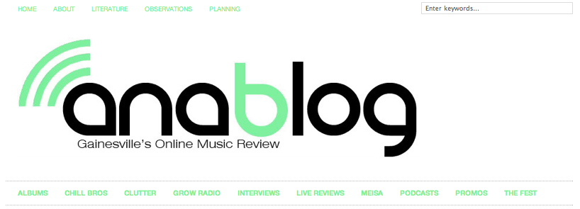
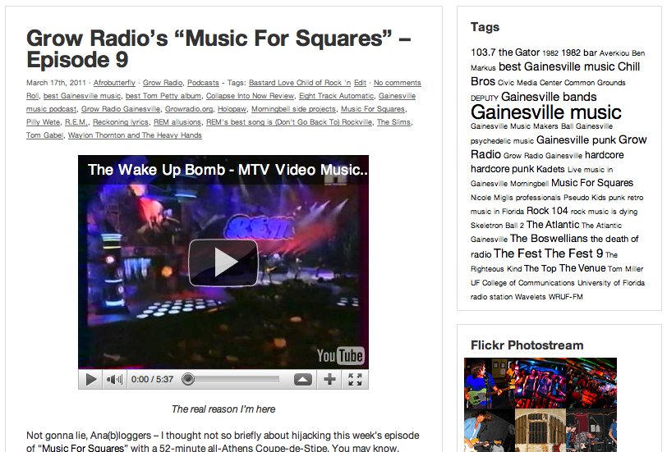
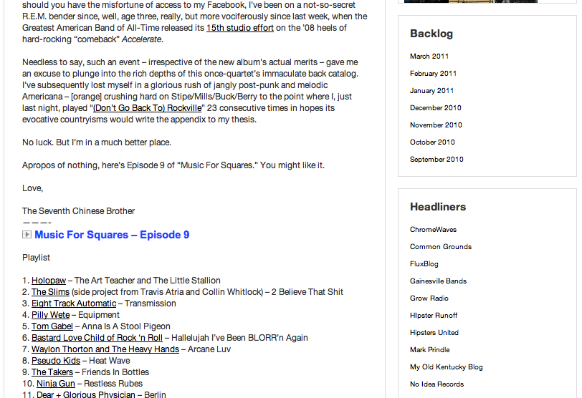

Defintition of Literature Review Terms
Social capital investment: the acquisition and development of information and interpersonal connections for the purpose of expanding one’s social networks. This definition is borrowed from Portes (1998), who defined social capital as “the ability of actors to secure benefits by virtue of membership in social networks or other social structures” (Alder & Kwon, 2002, p. 20).
Personal identity: the sense of individuality achieved through A) the acquisition of information or B) development of interpersonal connections perceived as distinguishing one from his or her peer group. This definition, borrowed from D’Arcangelo’s (2005) essay on music and personal identity, argues, “musical material provides terms and templates for elaborating self-identity” (p. 2).
Community participation: interaction with the blogger and other blog visitors through text-based communications. Commenting under individual posts was the primary medium of participation, but other examples included: joining the blog’s Facebook page, commenting on a Facebook fan page, tweeting the blogger and others in the community, linking and sending trackbacks from one’s own blog, subscribing to an RSS feed, and “liking” a blog post.
Identity disclosure: the sharing of personal information through avenues available on the blog. Examples include the posting of contact information, revealing of one’s real name (i.e. commenting without a pseudonym), and recounting anecdotal experiences.
Parasocial behavior: activity that cultivates a level of friendship with the blogger and other community members. This definition borrowed from Perse (1990), who characterized “parasocial” as “a pseudo-friendship with media personalities that connotes liking, perceived similarity and… attraction” (p. 21).
Habitual behavior: repetitive activity with a level of automaticity that pre-empts attitudes and intentions. This definition is borrowed from Bas Verplanken (2006), who used a similar meaning to distinguish habit from frequency in his analysis of negative thinking patterns.

