Adding Volumes to Existing Items
Overview of Steps:
- Create a spreadsheet with only the serial hierarchy information for the volumes to be added
- Use the SMaRT Tool to locate the item record
- Open the item record
- Click on the “Add Volumes” button
- Select your spreadsheet file and the sheet to use
- Click “Show Data” to see a preview of the imported data
- Click “Execute”
- Review the new volumes and make any corrections if needed

Step 1: Create a spreadsheet with only the serial hierarchy information
Examples:
  Year | Number
  1914 | 3
  1914 | 5
  1915 | 1
  Year | Month | Day
  2010 | 3 | 23
  2010 | 3 | 24
  2010 | 3 | 25
  2010 | 3 | 26
  Volume | Number | Issue
  4 | 1 | 1
  4 | 1 | 2
  5 | 1 | 1
  5 | 2 | 2
See the included example file for full examples.
Step 2: Use the SMaRT Tool to open the item record
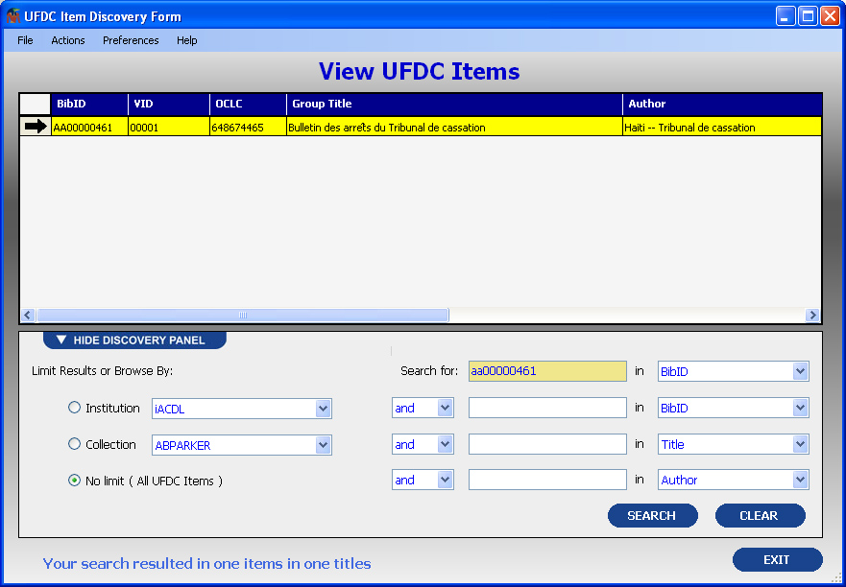
Step 3: Open the item record
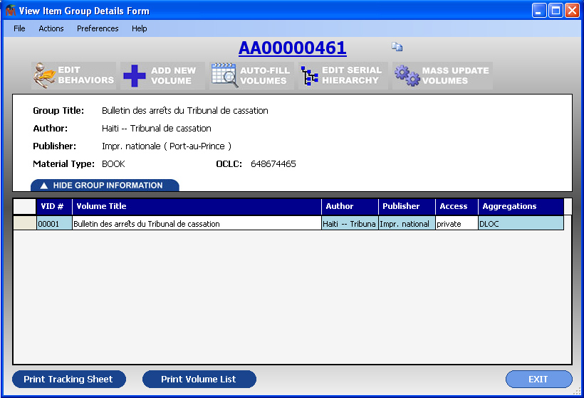
Step 4: Click on the “Add Volumes” button
Step 5: Select your spreadsheet file and the sheet to use
Step 6: Click “Show Data” to see a preview of the imported data
Step 7: Click “Execute”
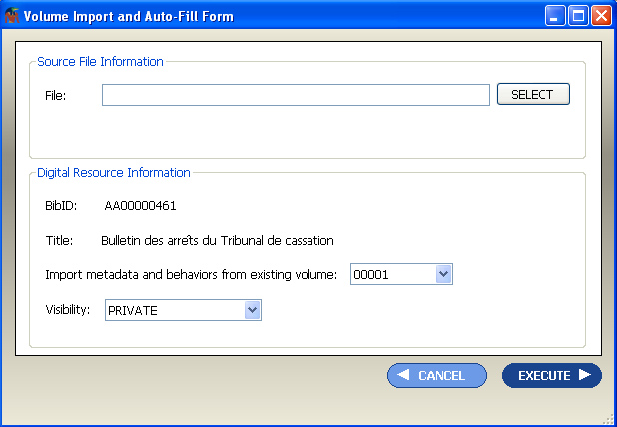
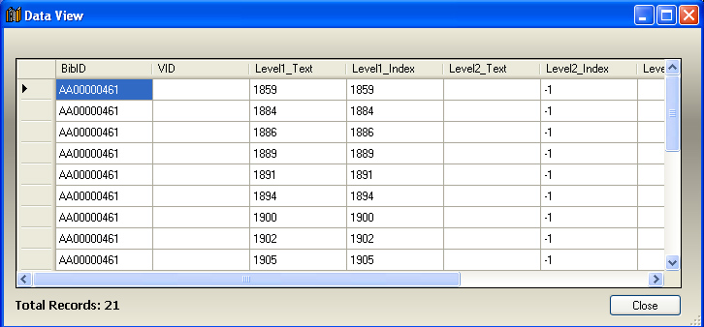

Step 8: Review the new volumes and make any corrections if needed 

