FSU Digital Library & Digital Humanities Collection
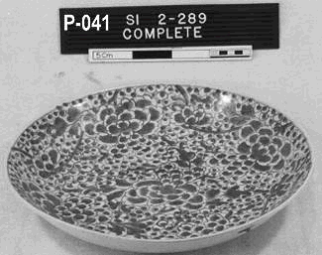
I’m always looking for other project examples of digital humanities and digital library collaborations. I’m especially interested in small and mid-scale examples, where researchers have data sets of digital files of their primary research materials. In some cases, these may be statistical data sets and in others these may be sets of files representing textual documents, image documents, artifacts, and others. Good examples of these data sets can be used to show how much primary resource documentation and digitization researchers conduct, how these resources are part of and inform the scholarly process, and how sharing these resources can enrich the final research publications and entire fields of research. Simpler examples of digital humanities’ needs are particularly useful because they show how researchers can do what they’re already doing, and how they and their field can benefit from collaborating with digital libraries to share their primary resources.
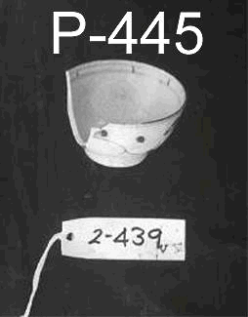
I recently learned about a great example of a collaborative digital library and digital humanities project at The Florida State University (FSU). The project has been completed and an article was published on it in 2008 (article: Plato L. Smith II, (2008) “Where IR you?: Using “open access” to extend the reach and richness of faculty research within a university”, OCLC Systems & Services, Vol. 24 Iss: 3, pp.174 – 184). The project was a collaboration between the FSU Libraries and an FSU anthropology faculty member, Cheryl Ward. Ward had 800+ artifact images of the Sadana Island Shipwreck Excavation of 1995-1998 in Egypt. The digital files for these were stored in an office on disc and had no metadata. Thus, accessibility and the supports for preservation were concerns. The collaboration for this project created a digital archive for the digital images of the Sadana Island artifacts, including creating metadata, and the digital files were archived within the FSU Institutional Repository (IR). The metadata for the images is here and the image view is here. Ward’s research includes many publications and news stories, as well as a wonderfully illustrated document entitled “Chinese Porcelain for the Ottoman Court: Sadana Island, Egypt.”
While this project is a relatively simple example, with a single set of images that could all be grouped together, it’s also a great example. It’s great because it clearly illustrates how easily digital humanities and digital libraries can collaborate together to create new, organized resources that support the collaborating researcher’s needs and scholarly work more broadly through access to primary materials with a specific research context to support the primary materials.
Selected References
- Sadana Island artifacts, in FSU’s Institutional Repository
- Plato L. Smith II, (2008) “Where IR you?: Using “open access” to extend the reach and richness of faculty research within a university”, OCLC Systems & Services, Vol. 24 Iss: 3, pp.174 – 184

