University of Florida Digital Collections (UFDC)
Tracking Database (Legacy software)

This is the documentation for the legacy Tracking Database application for UF's Digital Library Center. This documentation is archived for historical purposes and the new production tracking application, SMaRT, is documented online: http://ufdc.ufl.edu/software/smart

A few notes
Philosophy
It was our original intent to create a database and user interface that could hold every bit of information necessary to create the metadata for each resource. The database diagram on this site represents the attempt to do just this. The database was designed and implemented completely. The first phase of the user interface was also completed and screen prints can be found on this site.
As we progressed through this development, the enormity of the task became apparent. Making one application to track the details, hold every bit of metadata, and make each element editable and repeatable is a Herculean task.
We have now returned to the idea that the tracking database should primarily track the progress of each resource through the digital library. It does include some basic bibliographic data necessary to identify the resource, and it still does aid in the creation of metadata. However, we do not expect it to hold every bit of data.
Data Flow
When we begin working on a resource, this resource is either entered into the application manually, or imported from a MARC record. Whenever a MARC record is available, this is converted into MARC-XML and stored in a central depository. An example MARC-XML file can be found here.
When the scanning of the resource is complete, the Quality Control Application is used to create structural metadata for the book. This allows users to add the divisions and division hierarchy for each resource. When the resource leaves the Quality Control department, a METS file is created from the data in the tracking database, the MARC-XML file, and the data entered by the tech. A sample METS file can be found here.
The resource is OCR’d and then placed on line, using only the METS file to load into Greenstone and the University of Florida Digital Collections [UFDC]. During this process portion of the METS file are converted to the Greenstone Archive [GSA] format for loading. The sample GSA can be found here and the loaded resource used for each of these examples can be found online here.
Development Continues
Development continues on the application with changes likely to be seen to the database as well. New resource types, such as newspapers, will be added with their own unique properties. Additionally, audio and video has not yet been implemented. As with all large projects in the changing environment in which we operate, the evolution of this project continues.

Main Form Screen Prints
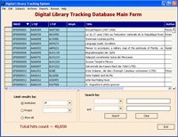 | This is the main form which is seen when the application is launched. This screen initially shows all the UF resources in the database. This form can also be used to search for single items from the list.
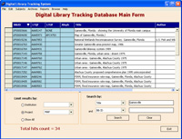 | Here we chose to search for all resources with the word 'Gainesville' in the title. Additionally, search results are limited to items in the MAP project (and all projects under MAP).
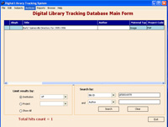 | A single resource can be located by searching for the bib id directly.

Monograph Item Screen Prints
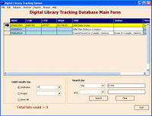 | Here we searched for all resources with the word 'Crump' in the title from the main screen. Next, we will drill down and view the details of this item.
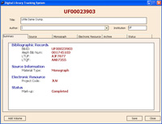 | The Summary panel displays some of the basic information about a single resource. This screen is readonly, and is used to give a quick view of data which might otherwise reside on seperate screens.
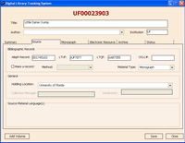 | The Source panel displays information about the original source document, including holding location and identifiers.
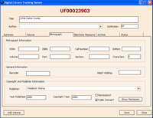 | The next tab is strongly related to the chosen resource type. The Monograph panel is used in this example. You can see an example of this panel for a serial here.
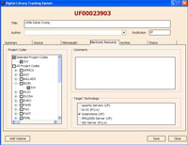 | The Electronic Resource panel allows us to set the project code and the destination technology. Additionally, comments about this resource can be included here.
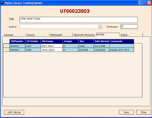 | The Archive panel shows which CD's or DVD's include the files from this resource.
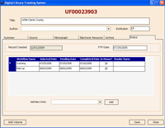 | The Status panel allows status to be tracked for this resource. If this was an item with multiple volumes, like a serial, this panel would not be shown as status would be reported individually for each volume.
The item used in this example is available online.

Serial Screen Prints
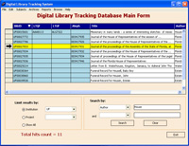 | Here we searched for all UF resources with the word 'House' in the author field from the main screen. Next, we will drill down and view the details of this serial.
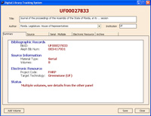 | The Summary panel displays some of the basic information about a single resource. This screen is readonly, and is used to give a quick view of data which might otherwise reside on seperate screens.
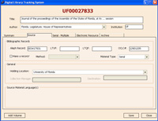 | The Source panel displays information about the original source document, including holding location and identifiers.
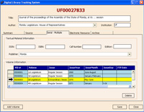 | The next tab is strongly related to the chosen resource type. Since this object is a serial, the Serial panel is shown. You can see an example of this panel for a monograph here. From this screen a user can click on a single volume to get more details.
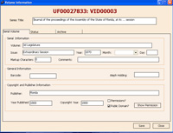 | We now selected a single volume from the list of volumes under this serial. This Serial Volume panel shows information about this volume.
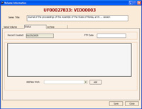 | Status is reported at the volume level, since this is a serial. This current volume has not been scanned, so there is no reported status.
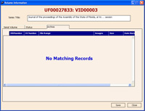 | You can view which CDs or DVDs the images for this single volume are on by viewing the Archive panel at the volume level.
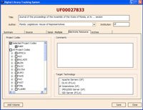 | Back at the serial level, the Electronic Resource panel allows us to set the project code and the destination technology. Additionally, comments about this resource can be included here.
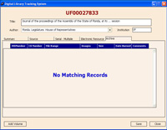 | The Archive panel shows which CD's or DVD's include the files from this resource. Since we are at the serial level, information would be reported for every volume under this serial.

Project Hierarchy Screen Prints
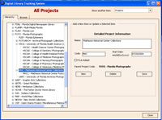 | The Hierarchy view displays the project structure to be viewed in tree format. From here, you can view and edit current projects, as well as add new projects.
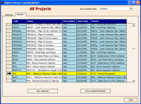 | The Browse view displays the collection of projects as a flat spreadsheet. You can also launch a search to see all items in a single project code from this screen.
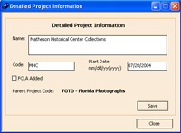 | We can edit and view the information about a single collection from this form.
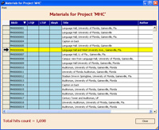 | We selected the 'MHC' collection and now can view all items in this project.

Archive Media Screen Prints
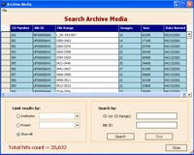 | The Archives form lets us view information about each of the CDs and DVDs in the local archive. Here, all items in the archive are displayed.
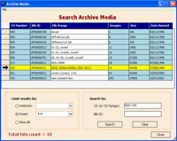 | We have now searched for all archived CDs and DVDs in the JUV project that reside in the range between CD number 500 and 725.
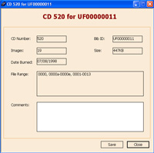 | Selecting a single row from the Archives form display the information for a single resource on the selected CD.

